#### Project Report on

**SECURITY SYSTEM WITH MOTION TRACKING USING THERMAL IMAGING AND TINYML**

#### by

|  |  |
| --- | --- |
| **Anway Pimpalkar** | **111907066** |
| **Kushagra Shrivastava** | **111907074** |
| **Ishita Rathor** | **111807046** |

#### Under the guidance of

**Dr. Shrinivas Mahajan**

Head of Department, Electronics and Telecommunications, COEP



DEPARTMENT OF

**ELECTRONICS AND TELECOMMUNICATION ENGINEERING**

**COLLEGE OF ENGINEERING PUNE 2021 – 2022**

**Abstract**

This report explores the

**Contents**

1. **Introduction** …………………..………………………………………………………… 1
   1. Literature Review …………………….……………………….…………………….. 1
   2. Aim …………………………………………………………………………….……. 2
   3. Objectives …………………………………………………………….……………... 2
2. **Theoretical Background** ……………………………..…………………………………. 3
   1. Peripheral Components ……………………………………………………………….. 3
      1. MQ-2 Smoke and Flammable Gas Detector …………………………………... 3
      2. LM-35 Temperature Sensor ………………………………………………….... 5
      3. Shift Registers …………………………………………………………………. 5
      4. OV7675 Camera Module …………………………………………………….... 6
   2. Comparator Circuit …………………………………………………………………… 6
   3. Feature Extraction in Signal Processing ……………………………………………… 7
      1. Fast Fourier Transform (FFT) ……………………………………………….… 7
      2. Spectrogram Analysis …………………………………………………………. 8
      3. Mel-Scale and MFCCs ………………………………………………………… 9
   4. Embedded Machine Learning ……………………………………………………….. 10
3. **System Architecture** …………………………………………..………………………. 12
   1. System Overview ……………………………………………………………………. 12
   2. Hardware and Software Overview …………………………………………………... 13
   3. Contactless Operation using KWS and VWW CNN Models ……………………….. 15
      1. Datasets ………………………………………………………………………. 16
         1. ‘COCO (Common Objects in Context)’ Dataset ………………………….. 16
         2. Generic Methodology for the CNN Models ………………………………. 17
      2. Generic Methodology for the CNN Models ………………………………….. 17
         1. VWW Model for Person Detection ……………………………………….. 18
         2. KWS Model for Speech Recognition ……………………………………… 21
      3. Multitenant Architecture for Running KWS and VWW Simultaneously …….. 28
   4. Fire Safety Unit Outside The Elevator ………………………………………………. 29
      1. MQ-2 Smoke/Flammable Gas Sensor …………………………………...…… 29
      2. LM-35 Temperature Sensor ………………………………………………..… 29
      3. System Working ……………………………………………………………… 30
      4. Fire Alarm System and Connection to Main Elevator Interface ……………… 31
   5. Fire Safety Unit Inside The Elevator ………………………………………………… 32
4. **Results, Analysis and Conclusion** ……….…………………………………………..... 34
   1. Hardware Implementation ………………………………………………..…………. 34
      1. Working and Results Achieved …………………………………………….… 35
         1. Setting Up …………………………………………………………………. 35
         2. Running Inference ………………………………………………………… 35
         3. Accuracy and Latency Observations ………………………………...…… 39
      2. Bridging the Gaps Between The Hardware and The Simulations ………….… 39
   2. Software Based Simulations ………………………………………………………… 39
      1. Display and Fire Safety System of the Outside (Floor) Unit on Proteus ……... 40
         1. Working Overview ……...………………………………………………… 41
         2. Limitations of the Simulation …………………………………………...… 44
      2. Fire Safety System Inside The Elevator Unit on TinkerCAD …………….…. 44
   3. PCB Design ………………………………………………………………………….. 46
      1. Schematic …………………………………………………………………….. 46
      2. Bill of Materials ………………………………………………………………. 47
      3. PCB Layout …...……………………………………………………………… 47
      4. 3D Renders of PCB …………………………………………………………... 49
   4. Conclusion …………………………………………………………………………... 50

**References** ...……………...………………………………………………………………… 51

**Appendix** …………………………………………………………………………………… 52

[A] PCB Design Schematic on KiCAD EDA ………………………………………. 53

[B] PCB (pcbnew) Layout on KiCAD EDA ……………………………………….. 54

**List of Figures**

Figure 2.1: Outer build of MQ-2 Gas Sensor ................................................................................. 3

Figure 2.2: Sensor build with outer mesh removed …………………………………………….... 4

Figure 2.3: Tubular Sensing element inside MQ-2 ……………………….................................... 4

Figure 2.4 NEB Package of LM-35 Temperature sensor ……………………………….............. 5

Figure 2.5: Working of Shift Registers ………..………………………………………………… 6

Figure 2.6: OV7675 Camera Module …………………………………………..............................7

Figure 2.7: Skeleton circuit of Comparator using Operational Amplifier ...................................... 8

Figure 2.8: Fast Fourier Transform …………………………………............................................. 9

Figure 2.9: Sample spectrogram with a color legend ……............................................................ 10

Figure 2.10: Sample MFCC ……………………………………………………..……………… 11

Figure 3.1: Generic Block Diagram for Implementation ………………….................................. 13

Figure 3.2: Sample images from the COCO dataset with identified human subjects .................. 16

Figure 3.3: VWW block diagram .................................................................................................. 18

Figure 3.4: VWW model architecture as shown using Netron ..................................................... 20

Figure 3.5 KWS block diagram …………………………............................................................ 22

Figure 3.6: Analog visualization of raw audio signals of the keywords ...................................... 23

Figure 3.7: Generated FFTs of the keyword audio signals ........................................................... 24

Figure 3.8: Generated frequency domain spectrograms of the keyword audio signals ................ 25

Figure 3.9: Generated MFCCs of the keyword audio signals ....................................................... 25

Figure 3.10 Architecture of KWS Model ..................................................................................... 26

Figure 3.11 Final Training Results of KWS Model …………….................................................. 27

Figure 3.12 Circuit for MQ-2 Smoke Detector ............................................................................ 30

Figure 3.13 Circuit for LM-35 Temperature Sensor ..................................................................... 30

Figure 3.14:Circuit diagram for Fire Safety Alarm Outside the Elevator ..................................... 32

Figure 3.15:Circuit diagram for Fire Safety Alarm Inside the Elevator ....................................... 33

Figure 4.1 Individual components used for the hardware setup …………………………............ 34

Figure 4.2: Hardware setup for the Arduino Nano 33 BLE Sense and OV7675 Camera ............. 35

Figure 4.3: Sample greyscale QCIF images of size 144 x 176 pixels with human subject ……... 36

Figure 4.4: Output of the VWW model inferences ....................................................................... 36

Figure 4.5: LED Indicators of the VWW and KWS model inferences ......................................... 37

Figure 4.6: Output of the KWS model inferences ......................................................................... 38

Figure 4.7 Outside Unit Simulation on Proteus ............................................................................. 40

Figure 4.8 Displaying the hardware output on the 7 Segment Display of the simulation ………. 41

Figure 4.9 (a) Simulation when all parameters are optimal ......................................................... 42

Figure 4.9 (b) Simulation when smoke detector is set to 0 (smoke present) ................................ 42

Figure 4.9 (c) Simulation when temperature is above 45oC and smoke detector is set to 0 …..... 43

Figure 4.10: Simulation state when an anomaly is detected on other floors …………………..... 43

Figure 4.11: Smoke detector circuit using IC741 …………………….......................................... 44

Figure 4.12 (a) Simulation when smoke is detected inside the elevator below threshold ………. 45

Figure 4.12 (b) Simulation when smoke is detected inside the elevator above threshold ………. 45

Figure 4.13: PCB Schematic on KiCAD EDA ............................................................................. 46

Figure 4.14: Bill of Materials for the PCB .................................................................................... 47

Figure 4.15: Four Copper layers of designed PCB ……………………....................................... 48

Figure 4.16: 3D View of the created PCB ………………………................................................. 49

**List of Tables**

Table 3.1 Arduino Nano 33 BLE Sense Specifications ........................................................ 14

Table 3.2 List of Hardware and Software components used ................................................. 15

Table 3.3: Utterances of the chosen keywords in the KWS dataset ...................................... 17

Table 3.4 KWS model summary specifications ……………………………………………. 27

Table 3.5: Logic Table for Alarm System ............................................................................. 31

**Abbreviations**

CNN: Convolutional Neural Network

KWS: Keyword Spotting

VWW: Visual Wake Word

PCB: Printed Circuit Board

# Introduction

Elevator, also called lift, car that moves in a vertical shaft to carry passengers or freight between the levels of a multistory building. It is a platform that could either be open or closed and is used for lifting or lowering both people and goods to upper and lower floors.

Structurally, elevators have not changed much since the 1800s. However, their control systems have been altered for modern elevators in ways that improve on speed and safety. Modern elevator systems have added technology installed in them. Some have phones that allow the occupant to call for help in the event of an emergency. Others are fitted with a trap door located at the ceiling that make escape possible in emergency situations.

Even though elevators still maintain their original purpose of transporting people across floors, these upgrades that exist in the status quo have agreeably increased the quality and the general user experience of these elevators.

# Literature Review

Studies have shown that a significant part of the population believes elevators are unreliable and hold certain levels of uncertainty especially during emergencies. Additionally, elevators are not recommended during fire emergencies, which puts the people inside and their safety at a huge risk, the lack of automation is also a big risk factor, particularly during a time of a public health emergency as we are experiencing. To conclude, the current elevator technologies are not intuitive and cognizant of the risk that they may cause to the users and therefore, certain aspects need to be further developed.

The improvements and upgrades we propose are two-fold. One aspect is incorporating a smoke detector system inside and outside the elevator. This subsystem curbs the risk of people getting stuck inside an elevator to a large extent since it informs the users about smoke being in immediate

vicinity and gives them two things based on where the user is:

1. Ample time to get out of the elevator safely if the user is inside.
2. Get help for the people inside if the user is outside.

The second part is a person and speech detector in the elevator system. This subsystem allows a person to verbally communicate to the elevator instead of pressing buttons. This feature is exceptionally useful in the current paradigm, where social distancing and sanitization are quintessential for one’s safety.

Therefore, our system not only maximizes sanitization, but it also ensures user protection to its apex. Our projectis a simple but a significant change to the way things work in the status quo by the increasing the efficiency and safety of the current elevators in use.

# Aim

###### To ideate and model a safer and smarter elevator system using a device which can be deployed to pre-existing elevators.

# Objectives

## To ensure a contactless and thus hygienic elevator operation.

## To ensure safety from fire hazards by using smoke detectors and temperature sensors inside and outside the elevator

1. To understand, analyze and apply the working of different types of sensors
2. To learn effective and functional circuit designing.
3. To understand the crucial memory constraints of a given microcontroller and development environment and attain maximum benefits from the limited architecture.
4. To understand the difference of using pure electronic circuits to achieve a given output versus using a hybrid hardware/software development platform such as Arduino to achieve the same.
5. To understand the types of PCBs and develop our own PCB for the given project.
6. To understand how to apply the gained knowledge to create a holistic deployable product.

# Hardware and Software Design

To build any product end-to-end effectively, it is of utmost importance to understand the components used thoroughly. Before diving into the design specifics of our prototype, we will take an overview of the components we used to build it.

# Peripheral Components

# In this project, we have used available state-of-the-art equipment to build a prototype of the security system. They are detailed in this subsection.

# FLIR T420bx Thermal Imaging Camera

# A picture containing indoor, light Description automatically generatedThe FLIR T420bx Thermal Imaging Camera is a state-of-the-art thermal imaging camera designed and manufactured by Teledyne FLIR *(Wilsonville, Oregon, United States)*. It has a temperature range of -20°C to 350°C and is cased in a portable handheld package.

# *Figure 2.1: FLIR T420bx Thermal Imaging Camera (Courtesy: Teledyne FLIR)*

The camera is powered by Multi-Spectral Dynamic Imaging (MSX) technology which adds visible spectrum definition to IR images in real time for excellent thermal detail. It can provide a Frame Rate of upto 60Hz for video recordings, as we used during our data collection step. By default, it is equipped with a 25° lens. It supports uncompressed colorized video streaming over USB.

# *Figure 2.2: (Courtesy: www.lastminuteengineers.com).*

# Raspberry Pi Model 4 (2GB RAM Variant)

# Lorem ipsum

# 

# *Figure 2.3 Raspberry Pi Model 4 used in our project.*

# Component 3

# Component 3 are used for

# *Figure 2.5: Working of Shift Registers*

*Table 3.1: Arduino Nano 33 BLE Sense Specifications.*

|  |  |
| --- | --- |
| **Feature** | **Specification** |
| Microcontroller | nRF52840, 32-bit ARM Cortex M4 CPU, 64 MHz |
| Operating Voltage | 3.3V |
| RAM | 256KB |
| Flash Memory | 1MB |
| Power | 5V / 3.3V |
| BLE | Bluetooth Low Energy enabled |
| Sensors | LSM9DS1-9 Axis IMU, HTS221 Humidity & Temperature Sensor, APDS9960 gesture detection, proximity detection, digital ambient Light Sense (ALS), and Color Sense (RGBC), LPS22HB Barometer, MP34DT05-A Microphone |
| Digital Pins | 14 (All PWM) |
| Analog Pins | 8 |
| Length | 45 mm |
| Width | 18 mm |
| Weight | 5 grams (with headers) |

A complete list of hardware and software tools used to build this project is listed in Table 3.2. The components were carefully chosen based on the characteristic features they offer. The reasons behind the choices are thoroughly explained in the chapter over various sections.

*Table 3.2 List of Hardware and Software components used.*

|  |  |  |
| --- | --- | --- |
| **Type** | **Component** | **Purpose** |
| Hardware | Arduino Nano 33 BLE Sense | Main development board, KWS Model |
| OV7675 Camera Module | VWW Model |
| MQ-02 Smoke/Gas Sensors | Fire safety systems |
| LM-35 Temperature Sensor |
| 74HC595 Shift Register | Interfacing a 7 Segment Display |
| 7 Segment Display | Displaying received floor number |
| IC741 | Operational Amplifier for Comparator |
| Resistors, Capacitors, LEDs, etc. | Circuit accessories |
| Software | Arduino IDE | Programming, compiling and uploading C++ sketches to Arduino |
| TensorFlow (Lite Micro) | Open-source software library for machine learning and neural networks |
| Netron | Open-source structure viewer and analyzer for CNNs |
| TinkerCAD | Online electronic circuit simulation software |
| Proteus Design Suite | Simulation software for advanced electronic circuits |
| KiCAD EDA | Facilitates the design of schematics for electronic circuits and their conversion to PCB designs |
| Programming  Languages | C++ | Programming the Arduino and interfacing sensors and modules to it |
| Python | For TensorFlow; Creating CNN models and Machine Learning Architecture |

# Object Detection using Deep Learning

# Machine learning is the science of getting computers to act without being explicitly programmed. These processes require a lot of computing power and memory to be present in the system on which it runs. A CNN model once compiled is in the order of MBs if not GBs. A typical GPU consumes power in the order of Watts. Deploying such models to embedded microcontrollers is a challenge because of the severe power and memory constraints.

# The solution is to make use of various quantization methods on the models to shrink down the size and power requirements to be deployable to embedded microcontrollers. This is done by using various methods such as quantization, pruning, etc. Some accuracy is lost in the process due to the reduces computes. The key is to find the balance between the size, latency, and accuracy for any given application.

# TensorFlow provides multiple APIs to streamline this process of shrinking down models to make them deployable to embedded systems. For this reason, TensorFlow has been used extensively throughout this project for building and deploying neural networks to Raspberry Pi.

# System Architecture

This section elaborates the methodologies employed in our work for building a security system based on thermal imaging. A brief overview of this section is as follows. We begin by introducing the basic structure of the project we chose to implement. Then we briefly describe the approach to implement the object detection aspect of the system. ADD MORE

## System Overview

The main aim of the system is to be robust and serve as a working prototype for a system which can be deployed in genuine security scenarios. The entire prototype is based on a Raspberry Pi Model 4, which has an array of features in-built into the board, of which we can take maximum advantage. A generic block diagram of the entire proposed system is represented in Figure 3.1.

Thermal Camera

Stepper Motor

Machine Learning Inference

Driver Code

Alarm



Hub

Communication Module

App



***Raspberry Pi***

User

*Figure 3.1: Generic Block Diagram for Implementation*

The project is a three-part system encompassing the following subsystems:

1. Human detection and tracking using a thermal imaging camera using TensorFlow Lite.
2. Web interface to show the status of the security system and stream the thermal camera stream to the application/interface.
3. Drive a stepper motor to follow the motion of the human detected in the frame based on the position of the human in the frame.

To implement the project, we selected components and controllers based on their availability, suitability, feasibility, cost, and ease of use. Most components were available within our college laboratories, which we used to avoid unnecessary expenses.

## Human Detection and Tracking

To implement this, we worked with TensorFlow. TensorFlow is a free and open-source software library for deep learning. It can be used across a range of tasks but has a particular focus on training and inference of deep neural networks. We used the concept of object detection to complete the human detection and tracking subsystem. We can summarize our work related to human detection and tracking as the following steps:

1. Collecting data using the *FLIR T 420 bx Thermal Imaging Camera*.
2. Cleaning the data, labeling it, and building a dataset suitable to train a detection model.
3. Building a machine learning model capable of detecting humans in the frames.

## Dataset

At the foundation of every artificially intelligent system is the data on which it is trained. We chose to build a strong dataset which can later be diversified to be annotated into more than one type of objects. The data was collected using the *FLIR T 420 bx Thermal Imaging Camera*. The data was collected using two methods, either by taking pictures and videos on the camera itself and extracting the data from the SD card, or by connecting the camera to a computer and accessing the stream via the *FLIR Thermal Studio*.

Since the system we developed was for human intruder detection, we chose to take images and videos focusing on two main labels:

1. Human subjects.
2. Backgrounds

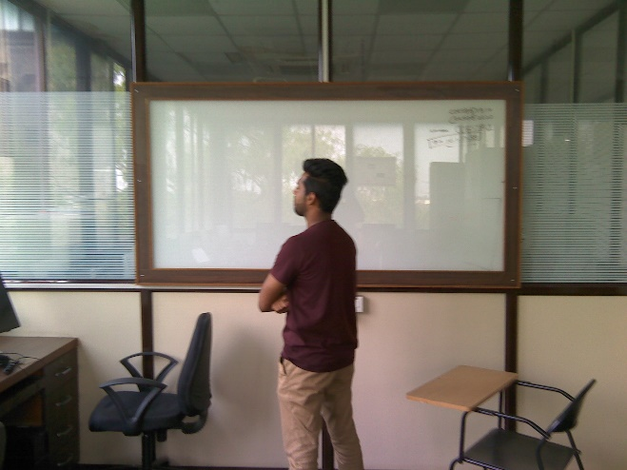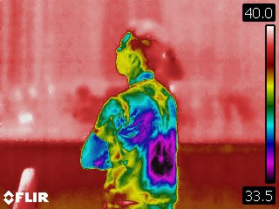

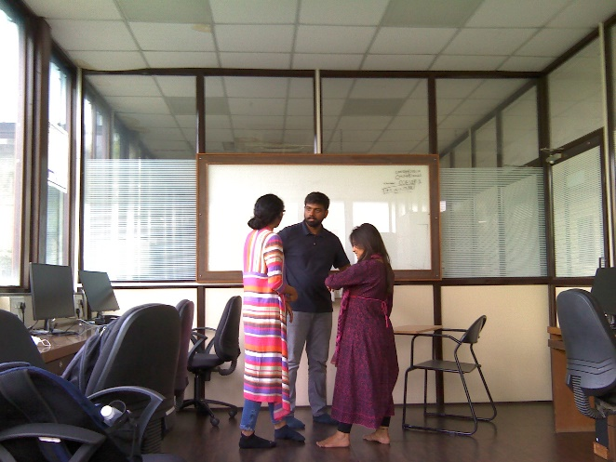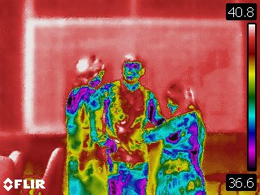

*Figure 3.2: Sample images collected using the FLIR T 420 bx Thermal Imaging Camera.*

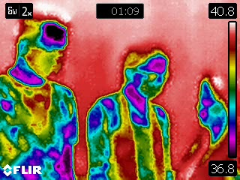 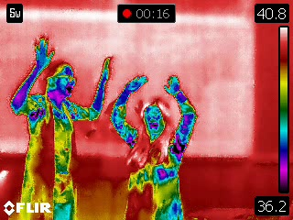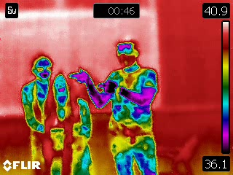 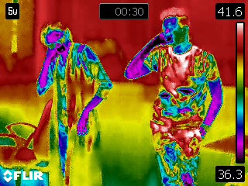

*Figure 3.3: Images with multiple human subjects in a single frame.*

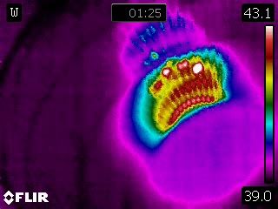 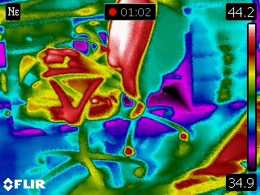

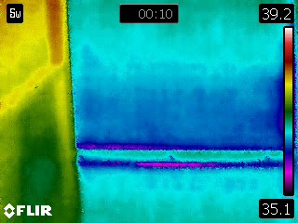 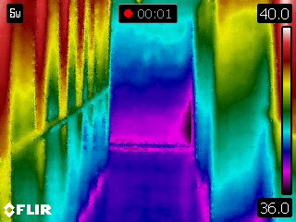

*Figure 3.4: Images with no humans (only background).*

A total of 90 photos and videos of human subjects, and 2 videos of background views were recorded and obtained. The videos were then split frame-by-frame using a Python script to create images which can be used to train the model. Post this split and some preliminary data cleaning, we had a total of 6,067 images with human subjects and 4,937 instances of backgrounds.

Considering the time it would have taken to train our model, we chose a small portion of this data to build the model, of 184 instances of humans, and 222 instances of backgrounds.

To label this data, we used a free open-source data labeler, *LabelImg*. The software allows for easy rectangular bounding of subjects in images, with annotations saved in XML files. This software had a limitation, it cannot add empty annotations to images with no human subjects. To fix this, we used a Python script to generate the annotations automatically for the background images from the dataset.

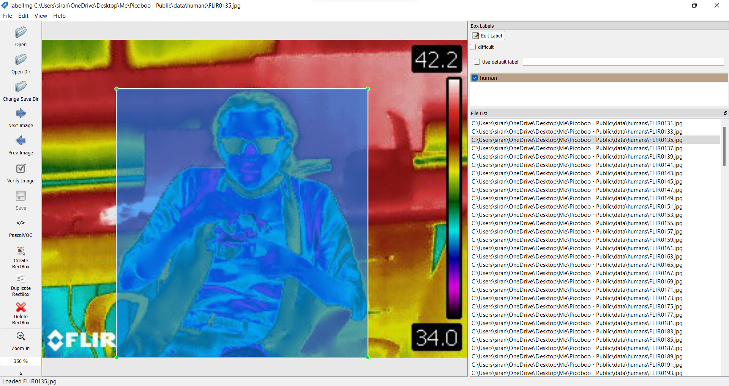

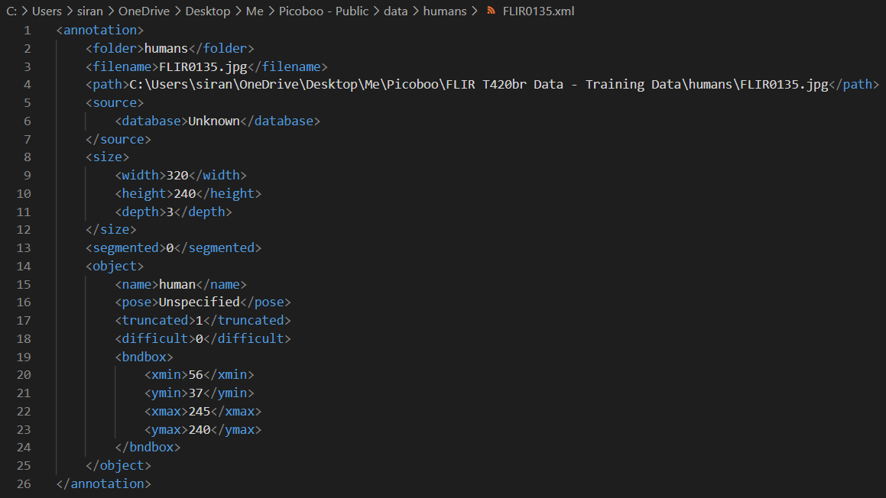

*Figure 3.5: Annotations creating using LabelImg for the dataset.*

In the data, we left the additional information captured as is, such as the temperature scale, the FLIR watermark and the current temperature reading. We hoped to create a model that would learn to ignore these features as background features. A summary of the created dataset is given in Table 3.1.

*Table 3.1: Dataset specifications.*

|  |  |
| --- | --- |
| Human Instances Captured | 6,067 |
| Background Instances Captured | 4,937 |
| Human Instances Used for Training | 184 (3.03%) |
| Background Instances Used for Training | 222 (4.4%) |
| Total Size | 39.6 MB |

### Object Detection Model using EfficientNet-Lite

The Object Detection model must have two key features – high accuracy with low latency. With extensive use of TensorFlow, we were able to build multiple models which took excellent advantage of the TensorFlow Lite library and performed well under limited power and memory environments such as the Raspberry Pi.

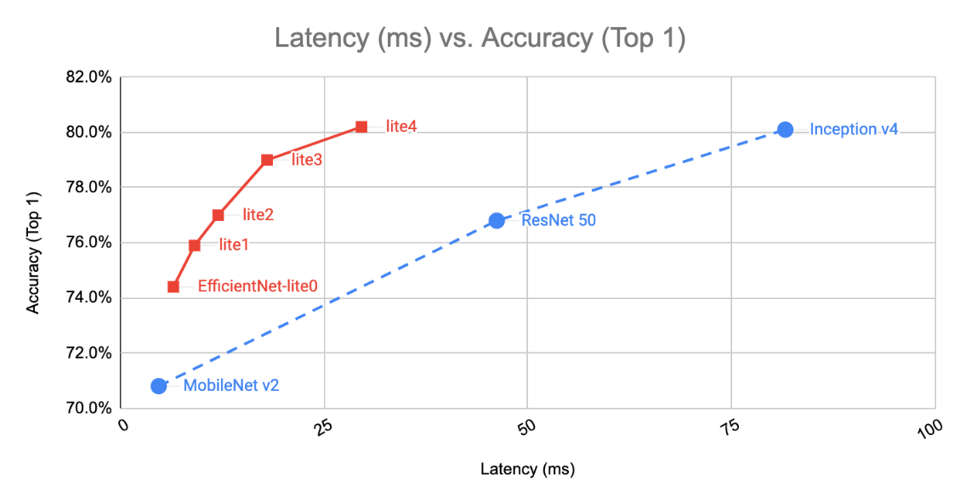In May 2019, Google released a family of image classification models called *EfficientNet*, which achieved state-of-the-art accuracy with an order of magnitude of fewer computations and parameters. They looked to optimize these models for deployment at the edge, and in 2020 they launched *EfficientNet-Lite* which runs on TensorFlow Lite and is designed for performance on mobile CPU, GPU, and EdgeTPU. EfficientNet-Lite brings the power of EfficientNet to edge devices and comes in five variants, allowing users to choose from the low latency/model size option *(EfficientNet-Lite0)* to the high accuracy option *(EfficientNet-Lite4)*. Below are how the quantized *EfficientNet-Lite* models perform compared to similarly quantized version of some popular image classification models.

*Figure 3.6: Comparison of EfficientNet-Lite models to different Image Classification models. (Courtesy: Google TensorFlow)*

To train our models, we used this *EfficientNet-Lite* series and checked their performance for our use-case. We started with the *EfficientNet-Lite0* baseline model using the *TFLite Model Maker*. The TFLite Model Maker library simplifies the process of adapting and converting a TensorFlow neural-network model to particular input data when deploying this model for on-device ML applications. After training the model on the *TFLite Model Maker*, it had to be quantized post-training to shrink it down. This created a flatbuffer for the model in TensorFlow Lite. Post-training quantization is a conversion technique that can reduce model size while also improving CPU and hardware accelerator latency, with little degradation in model accuracy. The *EfficientNet-Lite0 model* gave a *mean Average Precision (mAP)* of 67.7% on the validation dataset. Thanks to the TensorFlow Model Optimization Toolkit, we easily quantized the model via integer-only post-training quantization. This reduced the model size by 4x and improved inference speed by 2x. The mAP post-quantization was 69.09%, surprisingly higher than our pre-quantization mAP.

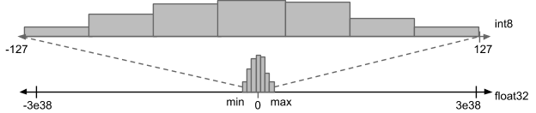

*Figure 3.6: Quantization Techniques. (Courtesy: Google TensorFlow)*

When the model ran on a given video stream, it ran at approximately 6 FPS. This was acceptable given our memory constraints and latency expectations. In an attempt to increase the accuracy, we also trained the model using *EfficientNet-Lite2.* This took considerably longer to train, but gave a higher mAP of 75.3%, which reduced to 72.6% post-quantization. Upon running inferences on our video stream, the frame rate dropped to approximately 2 FPS, which was impractical for our application.

The sizes of the models were considerably small. The *EfficientNet-Lite0* was a total of 4.2 MB, and the *EfficientNet-Lite2* was a total of 7.0 MB on the disk. This was an expected model size, considering the extensive architecture of the networks as observed on Netron. The complete data for the training of the models is given in Table 3.2.

*Table 3.2: Comparison of Model Hyperparameters.*

|  |  |  |
| --- | --- | --- |
| **Hyperparameter** | **EfficientNet-Lite0** | **EfficientNet-Lite2** |
| Learning Rate | 0.0090 to 2.2931e-05 | 0.0140 to 4.6005e-05 |
| Batch Size | 8 | 16 |
| Epochs | 20 | 20 |
| Size of Model | 4,341 KB | 7,212 KB |
| Training Time (No Hardware Acceleration) | 3,977 secs | 11,123 secs |

*Table 3.3: Comparison of Model Accuracies.*

|  |  |  |  |
| --- | --- | --- | --- |
| **Metric** | **Parameter** | **EfficientNet-Lite0** | **EfficientNet-Lite2** |
| Outputs | Size of Model | 4,341 KB | 7,212 KB |
| Training Time (no hardware acceleration) | 3,977 secs | 11,123 secs |
| Pre Quantization Metrics | mean Average Precision (mAP) | 0.6770454 | 0.75306594 |
| Average Precision with 50% IoU | 0.9646272 | 0.9970297 |
| Average Precision with 75% IoU | 0.8850385 | 0.91438556 |
| Average Precision with Medium Objects | 0.08974359 | 0.2025 |
| Average Precision with Large Objects | 0.70565706 | 0.7883744 |
| Average Recall with Medium Objects | 0.5 | 0.3 |
| Average Recall with Large Objects | 0.75555557 | 0.84444445 |
| Average Recall with Max 1 Object | 0.5 | 0.5736842 |
| Average Recall with Max 10 Objects | 0.74210525 | 0.81578946 |
| Post Quantization Metrics | mean Average Precision (mAP) | 0.69065887 | 0.7267763 |
| Average Precision with 50% IoU | 0.9431037 | 0.9970297 |
| Average Precision with 75% IoU | 0.8883388 | 0.93584985 |
| Average Precision with Medium Objects | 0.044444446 | 0.22777778 |
| Average Precision with Large Objects | 0.7259452 | 0.7535018 |
| Average Recall with Medium Objects | 0.4 | 0.7 |
| Average Recall with Large Objects | 0.76111114 | 0.7888889 |
| Average Recall with Max 1 Object | 0.52105266 | 0.5473684 |
| Average Recall with Max 10 Objects | 0.74210525 | 0.7842105 |

After using both the models, we decided to proceed with the *EfficientNet-Lite0* model. Using OpenCV to drive the video stream into the inference system, the model was deployed to the Raspberry Pi. The output images for both the models are shown in the image below. As seen in the top-left corner of the images, the latency of the *EfficientNet-Lite0* model is much lesser than the *EfficientNet-Lite2* model.

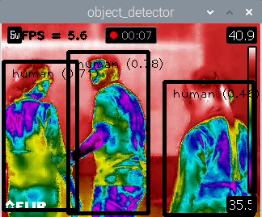 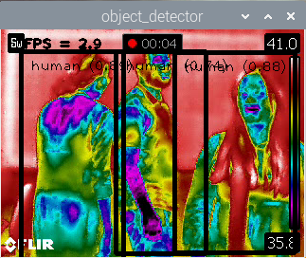

*Figure 3.7: Image Outputs of EfficientNet-Lite0 (left) and EfficientNet-Lite2 (right).*

* + - 1. **VWW Model for Person Detection**

The Visual Wake Word model used for our elevator use case is based on the existing MobileNets model. Training a VWW model from scratch takes days of time because of the massively cascaded architecture and large image sizes. This is the reason we chose to build our model based on this preexisting architecture and quantize it to suit our needs. MobileNets is a family of architectures designed to provide good accuracy for as few weight parameters and arithmetic operations as possible. There are multiple versions available, but in our case, we are using the original version since it required the smallest amount of RAM at runtime. The core concept behind the architecture is depthwise separable convolution. This is a variant of classical two-dimensional convolutions that works in a much more efficient way, without compromising

on accuracy too much. The model has various steps, as shown in Figure 3.3. Namely, these steps are Initialization, Pre-Processing, Model Inference, and Response.

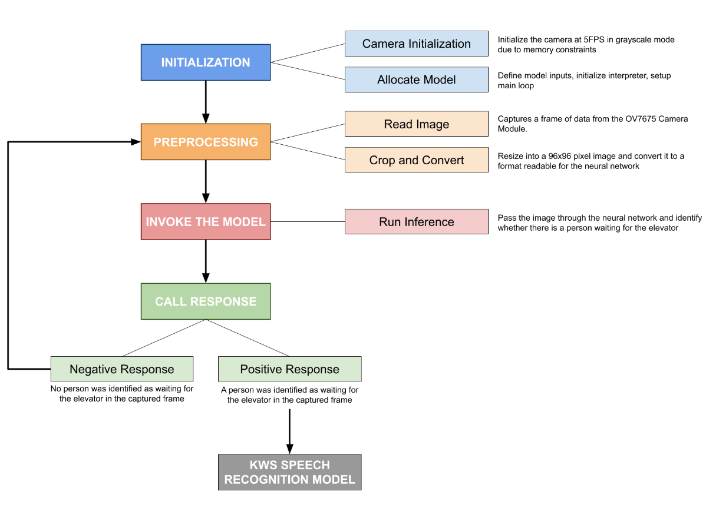

*Figure 3.3: VWW block diagram.*

1. **Initialization of the Model:**

In the first step of the cycle, the OV7675 camera module is initialized. For this specific application we initialized the camera at 5FPS grayscale mode due to the lesser memory requirements. The model is also allocated memory to run on the device. Further, we defined the model inputs, initialized the interpreter and setup the main loop of the model.

1. **Image Capture and Pre-Processing:**

Once the model is initialized, we are ready to start the inference process. We capture a 176 x 144 pixel image in QCIF (Quarter Common Intermediate Format) from the camera module and parse the frame data. The captured frame of data is then resized into a 96 x 96 pixel image and is converted to format which is readable for the CNN to run inference on.

1. **CNN Model and Inference:**

The preprocessed frame is fed to the CNN model for inference. The time taken for learning is greatly improved as well as the volume of data required for training the model is reduced significantly when fewer parameters are considered, and this is its practical advantage. The CNN is based on the pre-existing MobileNets model which is adequate for our purpose as discussed in the introduction of this section. The model has a 31-layer structure, including an iterating cascade of multiple DepthwiseConv2D and Conv2D layers. All these layers are equipped with ReLU activation layers to enable learning of non-linear mappings by the network. Earlier layers act more like edge recognition filters, spotting low-level structure in the image, and later layers synthesize that information into more abstract patterns that help with the final object classification. After the cascade, the data is pooled, fed through one final Conv2D layer, reshaped and passed through a SoftMax layer to normalize the output. The architecture summary of the model is shown in Figure 3.4.

While training the model, the data was augmented in multiple dimensions to introduce various methods for the recognition of distorted scenarios and images. The data was augmented in the following manners: horizontal shift of 10%, vertical shift of 10%, rotation range of 90o, horizontal flip and vertical flip.

The training of the model takes a couple of days on a single-GPU v100 instance to complete one-million steps, but we were able to build a fairly accurate model after a few hours to experiment early.

*Figure 3.4: VWW model architecture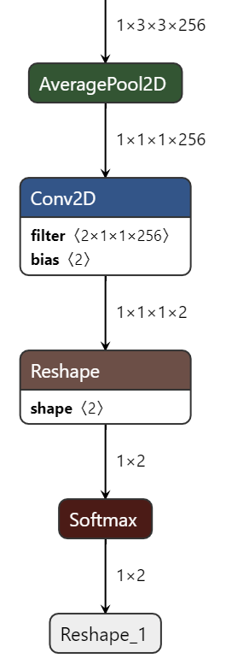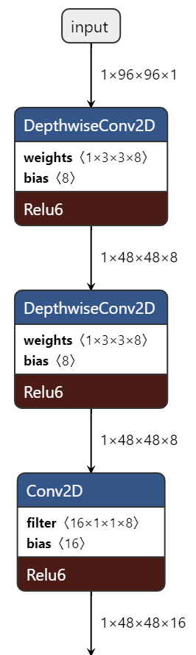 as shown using Netron.*

x 13 cascades (with varying weights, filters, and biases)

**…**

The accuracy of the model at a checkpoint we examined after 5179 training iterations gave an accuracy of approximately 72%. After the completion of one million training steps, we can expect the accuracy to rise to 84% with a loss of around 0.4 as listed by TensorFlow in the usage guide of the MobileNets framework.

Once the CNN model was trained using the TensorFlow and Keras APIs, the model was exported to TensorFlow Lite by freezing and quantizing the weights of the CNN. All the weights were converted to 8-bit integer values for low memory performance on the Arduino Nano 33 BLE Sense at the loss of some accuracy. We used the TFLiteConverter class to handle the quantization and conversion into the TensorFlow Lite flatbuffer file that we need for the inference engine. The flatbuffer file was further converted into a C-source data array file to be directly compiled into the Arduino hex file as the model source.

During inference, the preprocessed 96 x 96 pixel image is fed to the on-board model which was compiled. The inference checks for the presence of a human waiting in front of the elevator and represents the output as a “No person score” and a “Person score” on the scale of -127 to +127, where negative values represent a low probability of the positive outcome and positive scores represent a higher probability of a positive outcome.

1. **Call Response:**

If a person is detected in the given frame, the Arduino starts listening for audio commands which the person is giving to select a particular floor number by initializing the KWS model. If no command is found, then the system loops back to the Preprocessing step and captures another frame of data and reiterates the entire process for the next frame.

##### KWS Model for Speech Recognition

To enable a completely contactless experience for the elevator interface, we decided to go with a speech recognition approach to choose the floor number that a given user would like to go to. We went on to implement a KWS (Keyword Spotting) model to satisfy this requirement. The chosen keywords were floor numbers in the lower order “One”, “Two”, “Three” and “Four”. Like the VWW model, the KWS model has 4 high level steps in the system as shown in Figure 3.5. Compared to the prior, this model is relatively lightweight and takes lesser time for training and inference.

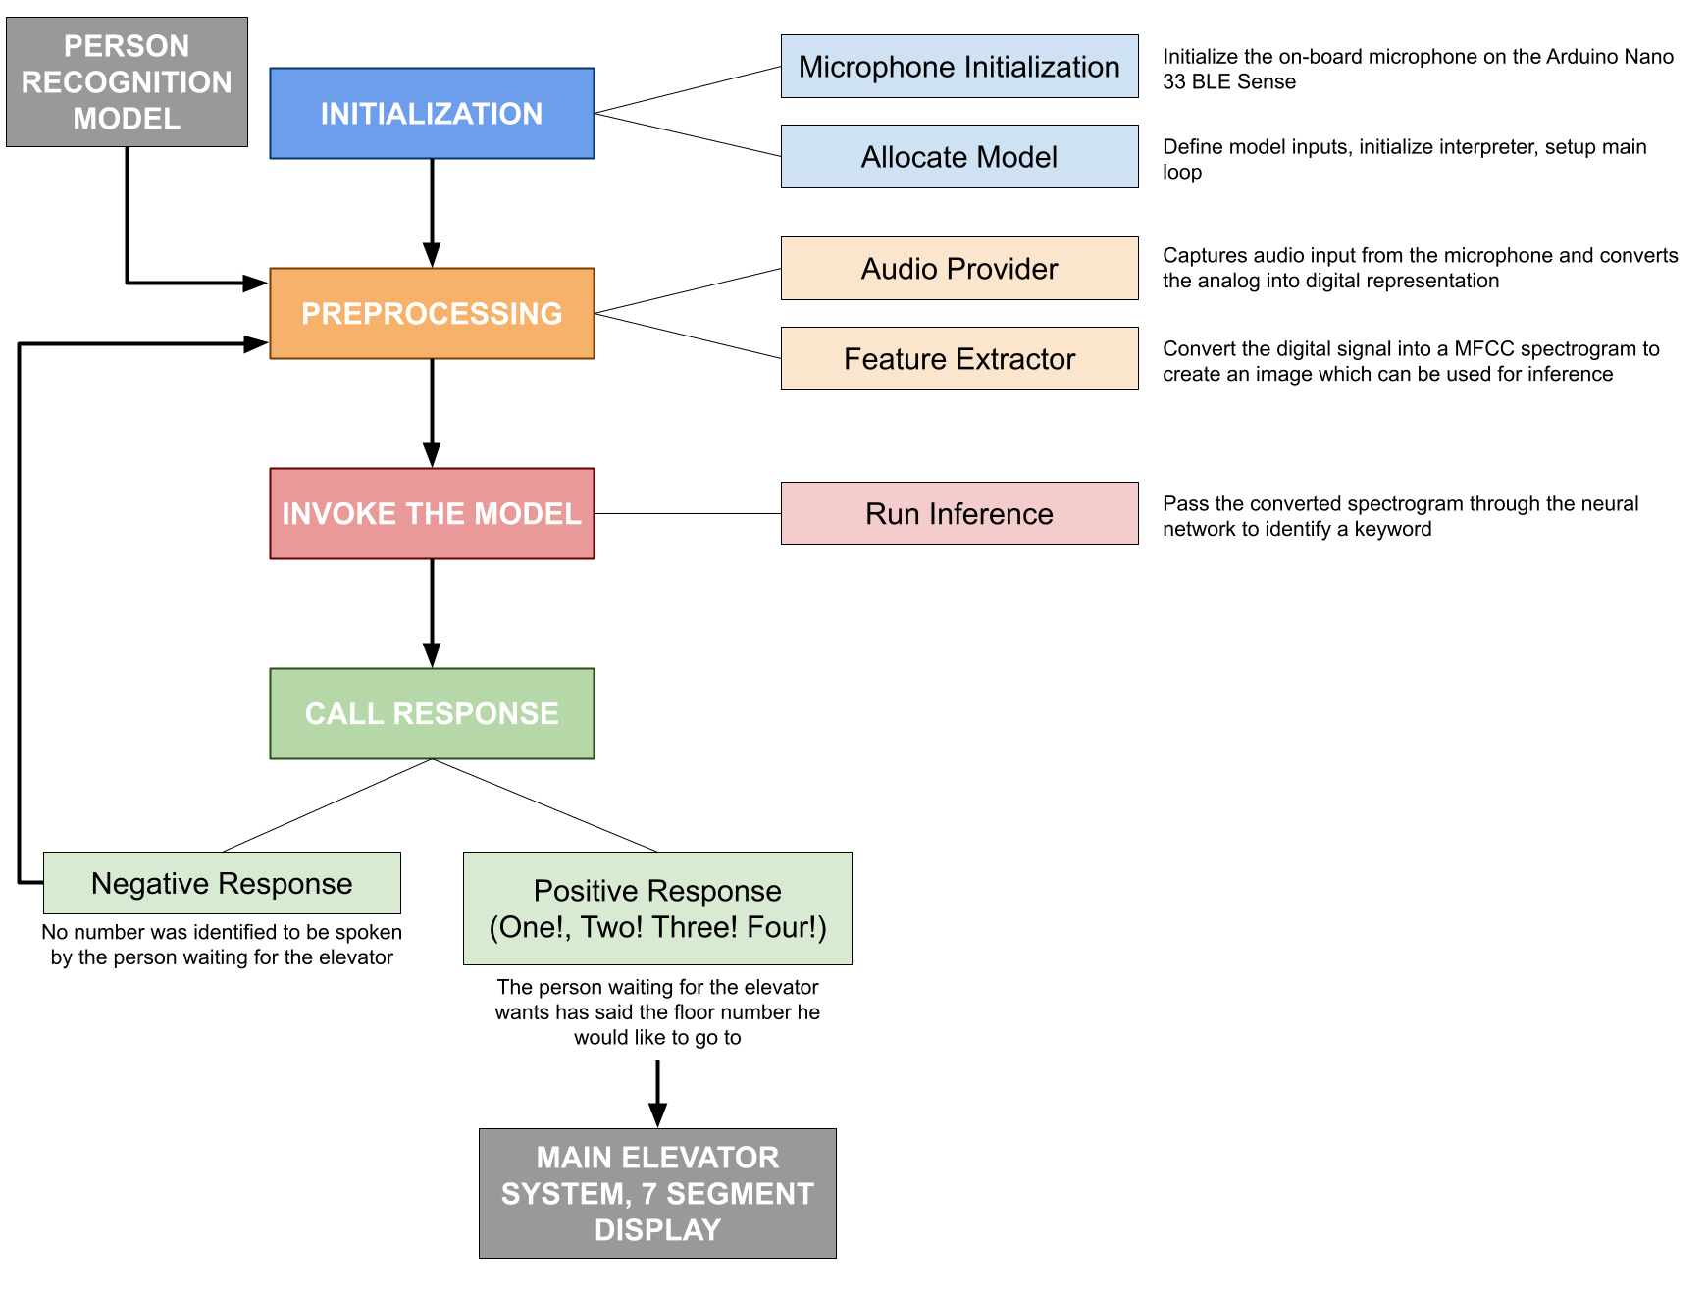

*Figure 3.5 KWS block diagram.*

1. **Initialization:**

During the initialization phase of the KWS model, the peripheral microphone required is setup and interfaced. Further, the model weights and inputs are defined, interpreter is initialized, and the main loop is setup. The required memory is allocated, and the required operators are resolved.

1. **Preprocessing:**

The preprocessing stage of the KWS model consists of two stages:

1. Audio Provider
2. Feature Extractor

These two systems collectively transform the raw input microphone data in to data which is interpretable and classifiable for the CNN. Both stages consist of various intermediate steps.

1. Audio Provider:

The audio provider stage sets up the microphone, reads a timeframe of data input and converts the incoming analog data into a digital representation. We sample the data at a rate of 16 kHz. The Analog to Digital conversion in the Arduino is handled by pre-existing libraries built into the Arduino. The digital representation of the data is loaded into an audio buffer continuously to be able to identify when a user says a particular keyword. The values are stored as 16 bit values in the buffer for the feature extractor to process. The input analog signals are visualized and shown in Figure 3.6 below.

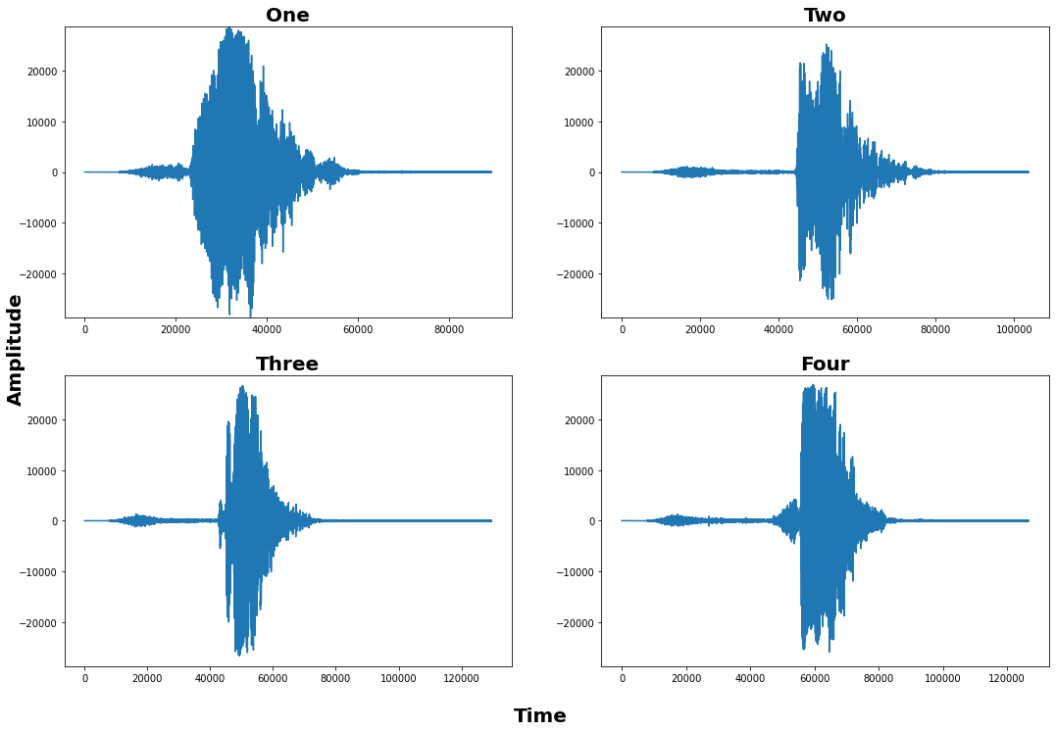

*Figure 3.6: Analog visualization of raw audio signals of the keywords.*

*(Note: These figures are recorded using our own voices and plotted using a Python Script.)*

1. Feature Extractor:

To make it easier for the CNN to process and classify the audio signals into different categories, we extract the features of the buffer audio sample before passing it into an inference pipeline. First, we take a 30 millisecond snapshot of the audio buffer and generate a FFT (Fast Fourier Transform) of it in 256 values. To make the FFT more robust, we average the 256 values of the FFT into 43 values. The FFT visualizations of the analog visualizations in Figure 3.6 are shown in Figure 3.7. These 43 values represent a single slice of the spectrogram we aim to generate. Each FFT represents a single column in the complete spectrogram of the audio buffer. Once one second’s worth of spectrogram data is obtained, a complete spectrogram is generated. The keyword representations as spectrograms are shown in Figure 3.8. Hence, the audio signal we currently possess is a time series signal, which we have converted into a frequency domain signal. In the frequency domain, we can do further optimizations and generate a MFCC (Mel Frequency Cepstral Coefficients) to understand features influenced by factors which are not comprehended by human ears. Our hearing mechanism naturally pick up low-frequency signals much better than higher-frequency signals. And, therefore, if we focus our effort or energy more on the low-frequency signals, then we are likely to pick up the words better.

The MFCC emphasizes the lower frequencies much more cleanly and that allows our machine learning model to pick up the signals for the keywords much more clearly. The generated MFCCs of our chosen keywords are shown in Figure 3.9. These MFCCs are then passed as inputs to our CNN model for inference.

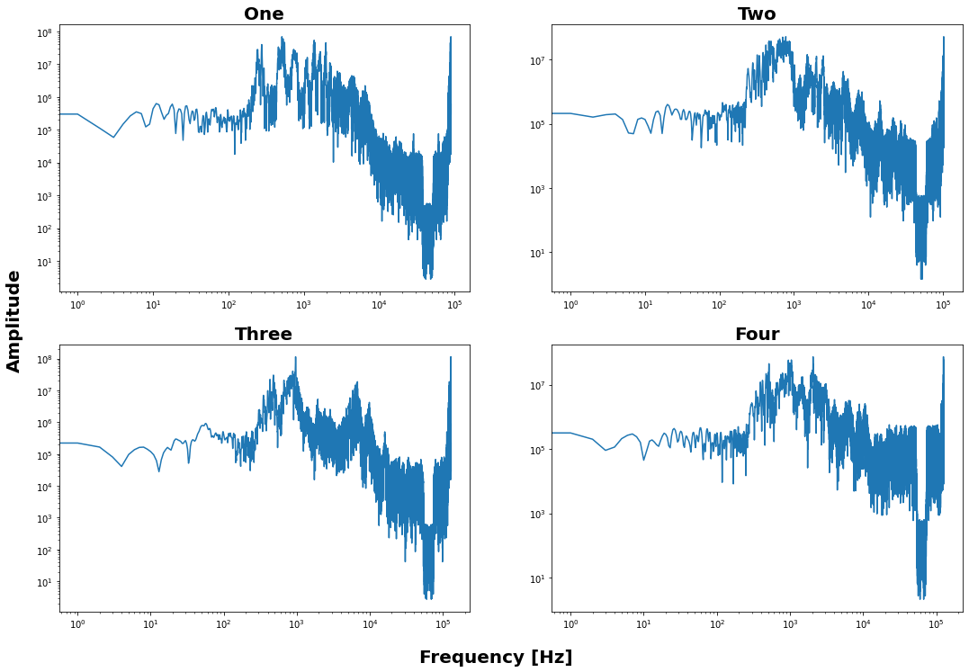

*Figure 3.7: Generated FFTs of the keyword audio signals.*

*(Note: These figures are recorded using our own voices and plotted using a Python Script.)*

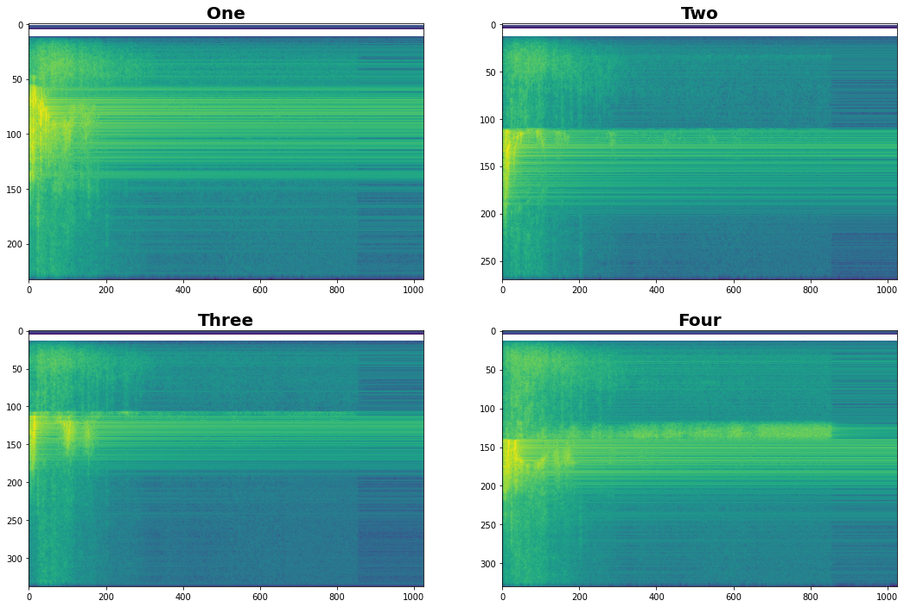

*Figure 3.8: Generated frequency domain spectrograms of the keyword audio signals.*

*(Note: These figures are recorded using our voices and plotted using a Python Script.)*

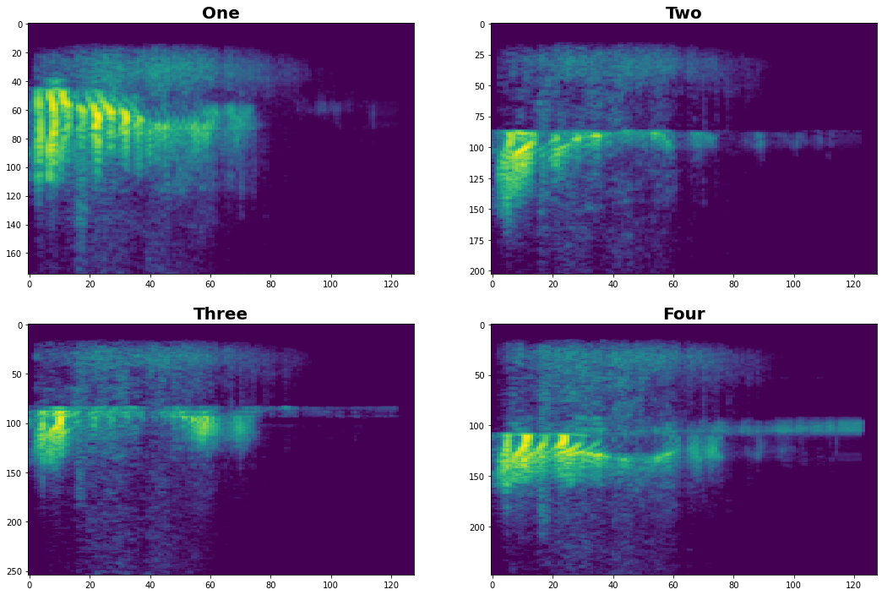

*Figure 3.9: Generated MFCCs of the keyword audio signals.*

*(Note: These figures are recorded using our own voices and plotted using a Python Script.)*

1. **KWS CNN Model and Inference:**

To identify a spoken keyword, we have built a basic CNN model based on the “tiny_conv” model architecture. The chosen neural network is built on this model to leverage its pre-optimized architecture for deployment to embedded microcontrollers. The tiny_conv architecture is lightweight and consists of a single DepthwiseConv2D and a FullyConnected followed by a Softmax layer for normalization. The architecture of t­­he CNN is as shown in Figure 3.10. A summary of the training parameters is given in Table 3.4. The final training result along with the confusion matrix is shown in Figure 3.11.

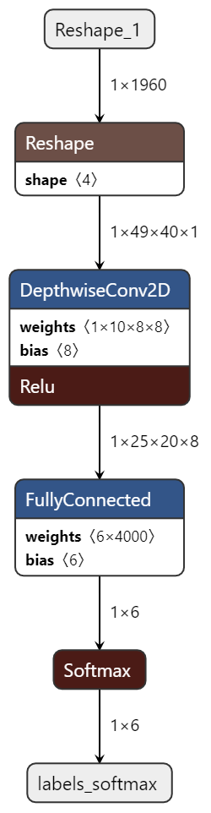

*Figure 3.10 Architecture of KWS Model.*

*Table 3.4 KWS model summary specifications.*

|  |  |
| --- | --- |
| **Parameter** | **Description** |
| Model Architecture | tiny_conv |
| Total Training Steps | 12,000 + 3,000 = 15,000 |
| Learning Rate For 12,000 Steps | 0.001 |
| Learning Rate For 3,000 Steps | 0.0001 |
| Sampling Rate | 16 kHz |
| Clip Duration Size | 1000 milliseconds |
| Window Size | 30 milliseconds |
| Validation Accuracy | 85.5% |
| Final Test Accuracy | 83.5% |

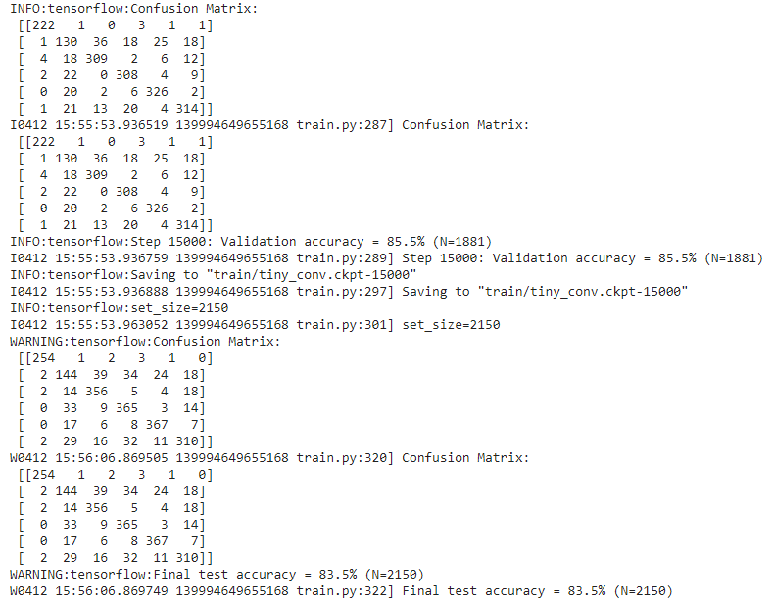

*Figure 3.11 Final Training Results of KWS Model.*

After the CNN model was trained using the TensorFlow and Keras APIs, the model was exported to TensorFlow Lite by freezing and quantizing the weights of the CNN, a common process for both the VWW and KWS model. All the weights were converted to 8-bit integer values for low memory performance on the Arduino Nano 33 BLE Sense at the loss of some accuracy. We used the TFLiteConverter class to handle the quantization and conversion into the TensorFlow Lite flatbuffer file that we need for the inference engine. The flatbuffer file was further converted into a C-source data array file to be directly compiled into the Arduino hex file as the model source, just as the VWW model.

During inference, we copy the feature buffer data to the input tensor. Then we pass the MFCC data through the CNN and attempt to classify the incoming data as one of the following categories:

1. “One”
2. “Two”
3. “Three”
4. “Four”
5. Unknown – unrecognized word input.
6. Silence – no word input detected.
7. **Call Response:**

Based on the outcome of the inference, the floor number (if detected) and sent to the main elevator interface and displayed on a Seven Segment Display. If there is no output found (i.e., Unknown or Silence category), then the system loops back at the preprocessing phase of the KWS model. If no data is found for 5 seconds of time, then the KWS loop is exited and the VWW model is executed from the preprocessing stage.

### Multitenant Architecture for Running KWS and VWW Simultaneously

Due to the memory and power constraints on any embedded microcontroller, running two CNN inference engines simultaneously is a challenge. Our approach to this problem was to implement a multi-tenant architecture for combining the KWS and VWW model. In such a structure, only one of the two models runs inference on the input data at a time. Both models share the TensorArena and use the same memory allocations. This allowed for fast inferences and efficient memory allocation when and wherever required. There is also no requirement for the synchronization of data streams from the camera module and the microphone, both of which are running at different sampling rates.

## Fire Safety Unit Outside The Elevator

Elevator shafts may be exposed to smoke and that smoke could reach occupants not just inside the elevator but on other floors as well. In such situations, the elevator is advised to return to the ground floor of the building immediately. The most efficient way to develop a fire safety system which protects the occupants of an elevator is to design a system which works in tandem with it the smoke/flammable gas detectors and temperature sensors directly. To maximize the efficiency of such a system, we developed a pipeline in which the main elevator interface has direct inputs from the smoke detection units. Depending on the levels obtained from the sensors, the elevator interface can further be commanded to execute a specific set of instructions, for example taking the elevator to the lowest floor immediately in the case of a fire.

To implement our approach, we chose to use a MQ-2 Smoke/Flammable Gas Detector and a LM-35 Temperature sensor.

###### MQ-2 Smoke/Flammable Gas Sensor

MQ-2 is one of the commonly used gas sensors in real world applications. It is a Metal Oxide Semiconductor (MOS) type Gas Sensor (also known as chemiresistors) as the detection is based upon change of resistance of the sensing material when the gas comes into contact with the material.

The key factors we considered while choosing this sensor:

1. Using a simple voltage divider network, concentrations of gas can be detected.
2. It can detect LPG, Smoke, Alcohol, Propane, Hydrogen, Methane and Carbon Monoxide concentrations anywhere from 200 to 10000 ppm.

###### LM-35 Temperature Sensor

The LM35 series are precision integrated-circuit temperature devices with an output voltage linearly proportional to the centigrade temperature. This is an industrial standard sensor which is readily available for use.

The key factors we considered while choosing this sensor:

1. Highly accurate across a variance of temperatures which our use case required.
2. Small module and easy for deployment.
3. Using a simple voltage divider network, accurate temperature readings can be obtained.

###### System Working

The MQ-2 Detector and the LM-35 Temperature sensor are connected to the microcontroller as per the specifications given in their respective datasheets. The provided connections for both the sensors are shown in Figure 3.12 and Figure 3.13, respectively.

The output voltages are given to analog input/output terminals of the Arduino Nano 33 BLE Sense. Using the *analogRead()* API provided by Arduino which accesses the on-board 10-bit analog to digital converter. The microcontroller maps input voltages between 0 and the operating voltage(5V) into integer values between 0 and 1023. This process yields a resolution between readings of 5 volts / 1024 units or, 0.0049 volts (4.9 mV) per unit. On our chosen microcontroller, it takes about 100 microseconds (0.0001 s) to read an analog input, so the maximum reading rate is about 10,000 times a second.

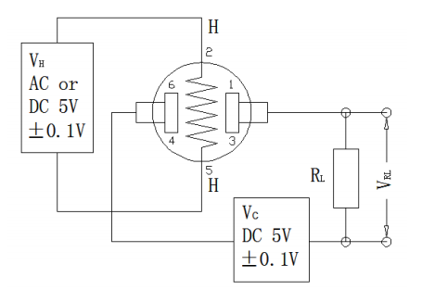

*Figure 3.12 Circuit for MQ-2 Smoke Detector.*

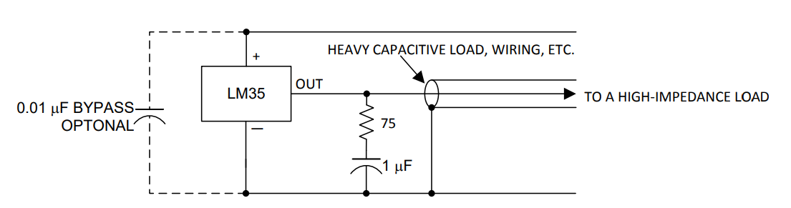

*Figure 3.13 Circuit for LM-35 Temperature Sensor.*

Due to the limitations of our simulation, there was no on-board ADC available and hence, we programmed the Arduino to do the conversion manually for the LM-35 Temperature sensor using the following formula:

$Temperature \left(Celsius\right)=V_{out }∙\frac{1100}{1024*10}$ (3.1)

For the detection threshold, we chose values which are abnormally high enough to indicate that the building has a fire present. For the temperature sensor, an alarm system was triggered once the temperature crossed 45oC. The smoke detector we used in our simulation software did not have an analog output capability and hence we triggered it as a binary device indicating presence of smoke/no smoke.

We placed a condition on the system such that if either the smoke detector output is positive or the temperature reading is above 45oC, then an alarm system is triggered which delivers an output to a logical buzzer circuit as well as conveys the status to the central elevator system.

###### Fire Alarm System and Connection to Main Elevator Interface

###### In the situation of a fire, the entire building as well as the central elevator interface must be notified at once. To create a robust system for handling this, we created a logic table as shown in Table 3.6. The system is based on the presence and absence of a digital HIGH signal from the Arduino Nano 33 BLE Sense.

###### Comparing the outputs required for the execution of the logic, we decided to use an Exclusive-OR Gate to execute the logic. By this, if a fire is present in a given situation, then the alarm circuit is triggered and the connection from the main elevator interface is lost. If there is no signal from a given floor, the main elevator interface flags it and immediately grounds the elevator. In the absence of a fire, the elevator resumes normal operation. The circuit for this alarm mechanism is shown in Figure 3.14.

*Table 3.5: Logic Table for Alarm System.*

|  |  |  |
| --- | --- | --- |
| **Arduino Signal (Input)** | **Main Elevator Interface (Output)** | **Fire Safety Alarm (Output)** |
| 1  (No Fire) | 1  (Signal present, hence, no fire) | 0  (Not triggered) |
| 0  (Fire) | 0  (Signal absent, hence presence of anomaly) | 1  (Triggered) |

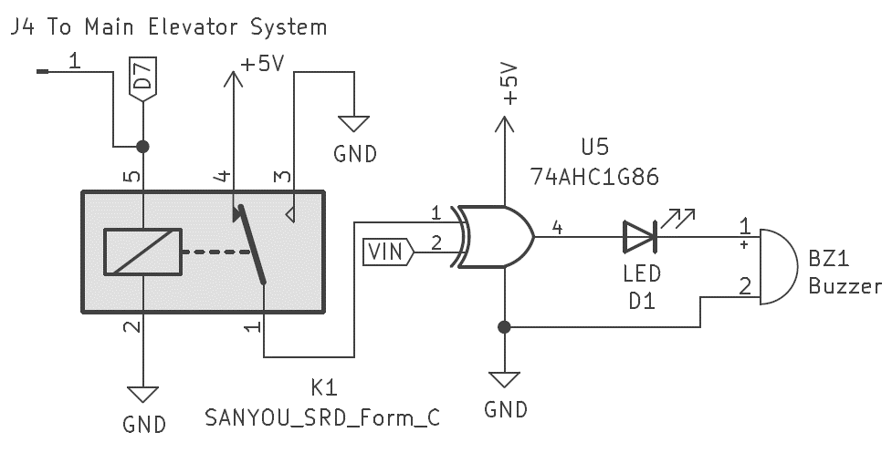

*Figure 3.14:Circuit diagram for Fire Safety Alarm Outside the Elevator.*

###### For this, we employed the 74AHC1G86 EX-OR Gate IC. It is a two-input single EX-OR gate IC. The key factor we considered while choosing this element was the simplicity required for the execution of the purpose. This was used in the fire detection alarm system buzzer and LED.

## Fire Safety Unit Inside The Elevator

In the case of an electrical malfunction or fire hazard inside the elevator, the users must be immediately evacuated and taken to safety. For such reasons, an independent fire safety alarm system is necessary. We implemented this using a simple comparator circuit based on an IC741 Operational Amplifier. An operational amplifier is a high-gain electronic voltage amplifier with a differential input and a single-ended output. The key factors we considered while choosing this element:

1. The IC741 is a broadly used single input Op-Amp IC which aptly fulfilled our requirements.
2. It is a reliable system with ease of use.

The details of a comparator circuit as were discussed in the Theoretical Background chapter serve as the basis for the smoke detector circuit we have assembled here. The circuit diagram of the circuit is as shown in Figure 3.15 and is in accordance with the circuit diagram as obtained for the MQ-2 in Figure 3.12.

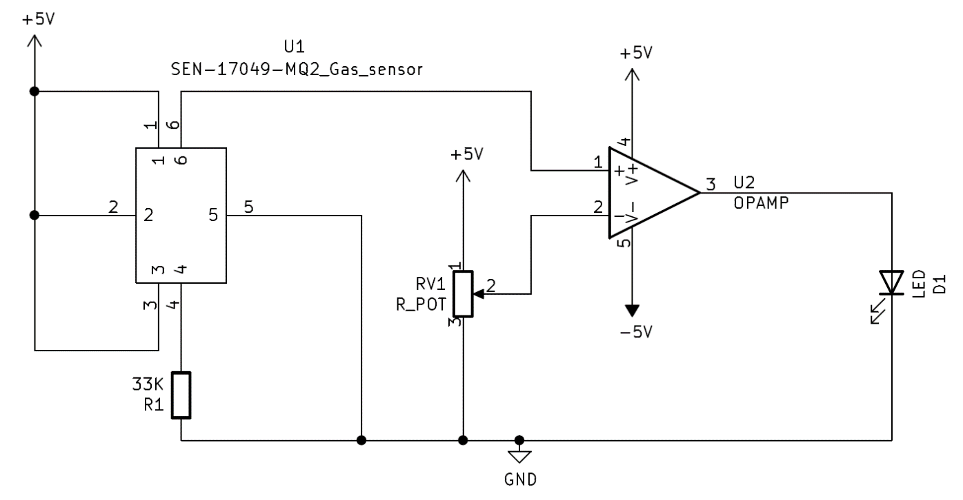

*Figure 3.15:Circuit diagram for Fire Safety Alarm Inside the Elevator.*

By adjusting the reference voltage on the potentiometer, we can increase or decrease the sensitivity of the circuit as required. The output of the comparator circuit is an LED in the given circuit but can also be a sound-based alarm system such a buzzer or a siren. The output of the circuit is also given to the main elevator interface as shown in the general block diagram Figure 3.1. The practical values of the circuit are discussed in the Results and Conclusion chapter.

# Results, Analysis and Conclusion

The implementation of this project was carried out in two stages based on the availability of parts and components. The VWW and KWS models for the contactless elevator system were implemented using hardware on an Arduino Nano 33 BLE Sense module. The rest of the subsystems were implemented on simulation softwares including Proteus Design Suite and TinkerCAD based on the necessities and additional features which are required.

## Hardware Implementation

The hardware required for the implementation of the contactless elevator system, i.e., the VWW and KWS models was readily available with us, namely the Arduino Nano 33 BLE Sense and OV7675 Camera Module. They are mounted on a shield for the scope of this experiment. Further into the implementation, we designed our own shield to house the OV7675 and Arduino module along with other peripherals.

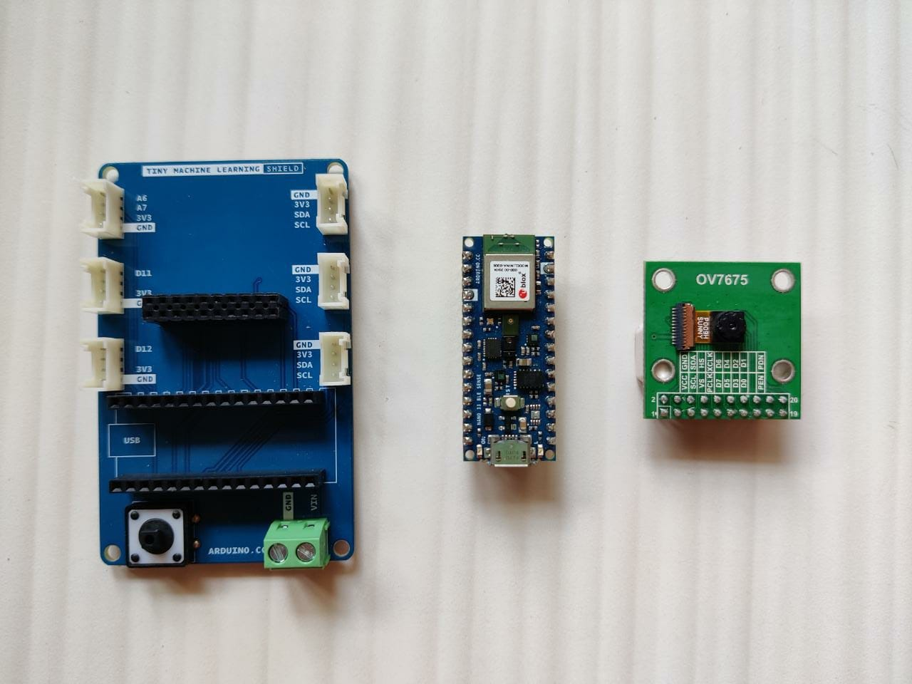

*Figure 4.1: Individual components used for the hardware setup.*

### Working and Results Achieved

Once the created KWS and VWW models were deployed onto the Arduino, we were able to run inference in particular test cases.

### Setting Up

The field of view of the camera module is moderately narrow. The best resolution is obtained when the camera is at least roughly an arm’s length from the human subject for the VWW model to run efficiently. We found the best results when the shield is propped up against a vertical surface. The microphone feature occasionally struggles to be accurate from such distances, but the efficiency can be increased using directional microphones instead of on-board default microphones in the future.

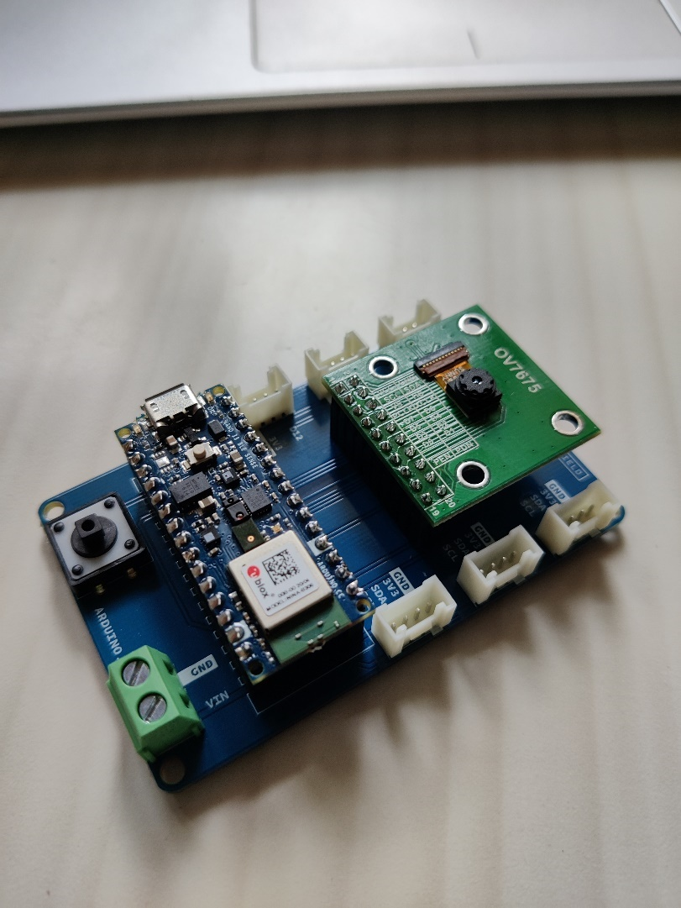

*Figure 4.2: Hardware setup for the Arduino Nano 33 BLE Sense and OV7675 Camera*

### Running Inference

Once the shield was properly positioned, we ran inference by standing inside and outside the frame of the camera. As discussed in the System Architecture chapter, each inference returns a probability value between -127 and +127, where higher numbers indicate a higher probability of a human subject being present in the frame. Sample greyscale QCIF images of size 144 x 176 pixels with human subject are shown in Figure 4.3. These images when fed to the model algorithms on-board give a positive output after inference. Although these images are distorted and incomplete, the algorithm is able to recognize adequate features to correctly identify a human subject because of the vast MobileNets training parameters and dataset.

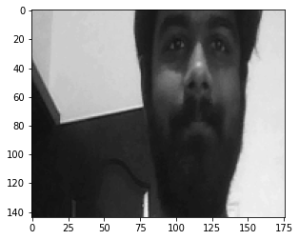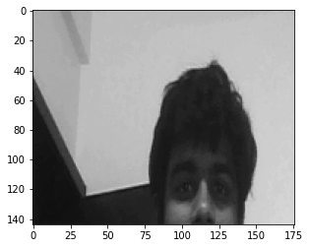 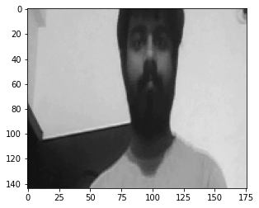

*Figure 4.3: Sample greyscale QCIF images of size 144 x 176 pixels with human subject.*

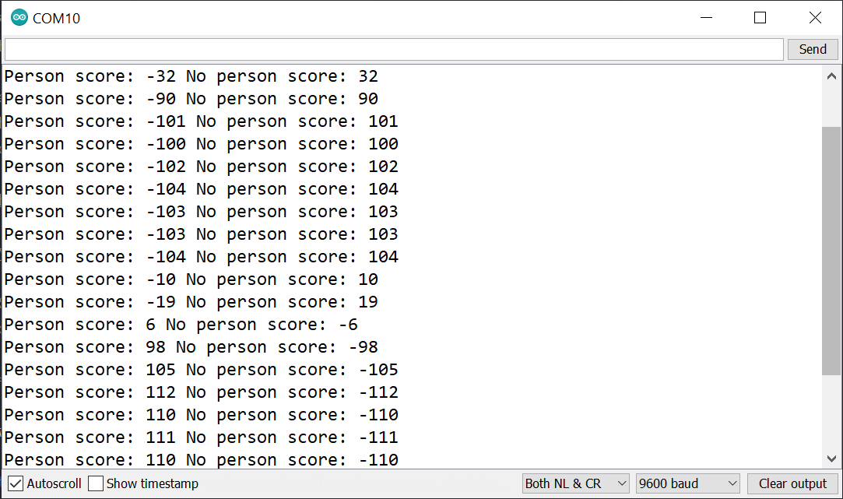

Person score < No person score:

No person detected in the given frame

Person score > No person score:

Person detected in the given frame

Person score ≈ No person score:

The model is indecisive for a moment when a subject is entering the field of view

*Figure 4.4: Output of the VWW model inferences.*

Once the inference engine is run, the probability values are generated. These values are printed on the serial monitor of the Arduino IDE as shown in Figure 4.4. When a person is entering the frame or in motion, the camera is unable to pick up the fast movement due to the low frame rate. At such moments, the model is decisive of whether a person is the frame or not. Hence, while classifying as a human detected in the field of view, we chose to keep a minimum Person score of 25. This threshold value reduces the number of false positives. If a person is detected in the frame, the green RGB light on the Arduino is lit up, whereas when there is no person detected, the red RGB light is lit up as shown in Figure 4.5.

Once a person has been detected in the frame, the KWS model inference engine is triggered, and the system starts listening for keywords spoken by the user to communicate the floor number which they would like to go to. These numbers are chosen to be “One”, “Two”, “Three”, and “Four”. The incoming audio is sampled at 16 kHz and ran inference on every one second. Whenever the Arduino is listening for a keyword, the yellow light rapidly blinks, and upon positive inference, the blue RGB light is lit up.

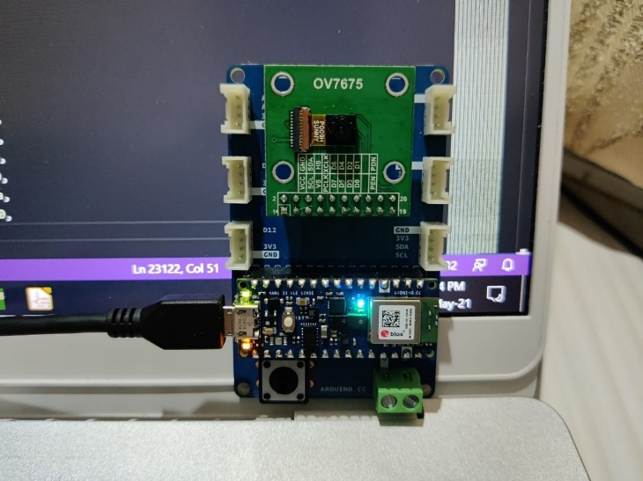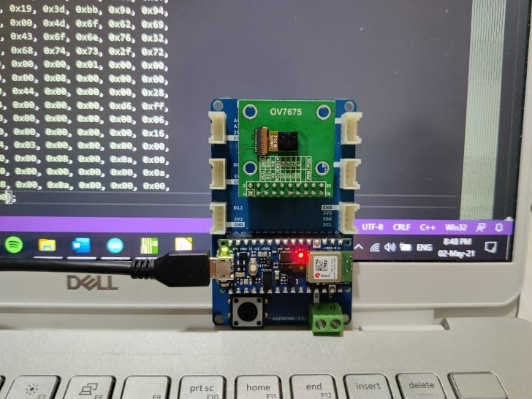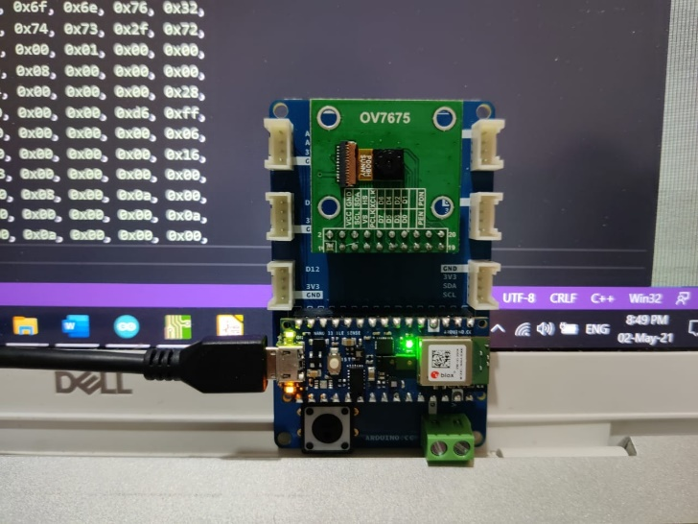

*Figure 4.5: LED Indicators of the VWW and KWS model inferences.*

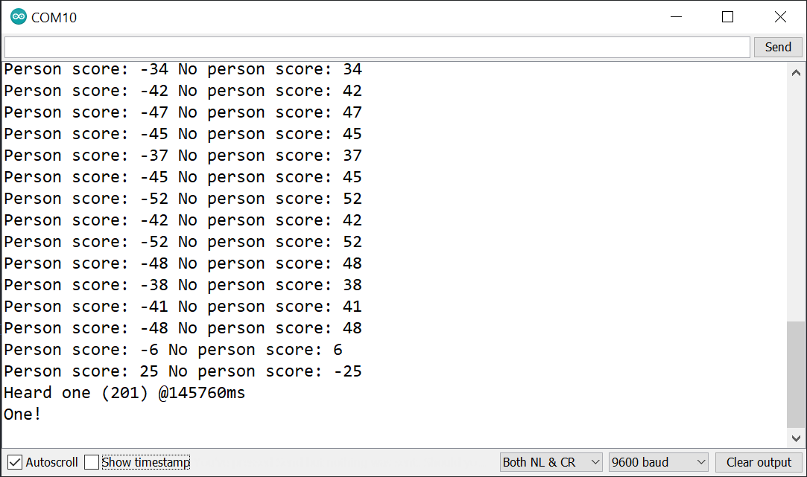

Person detected

Heard the number “One”!

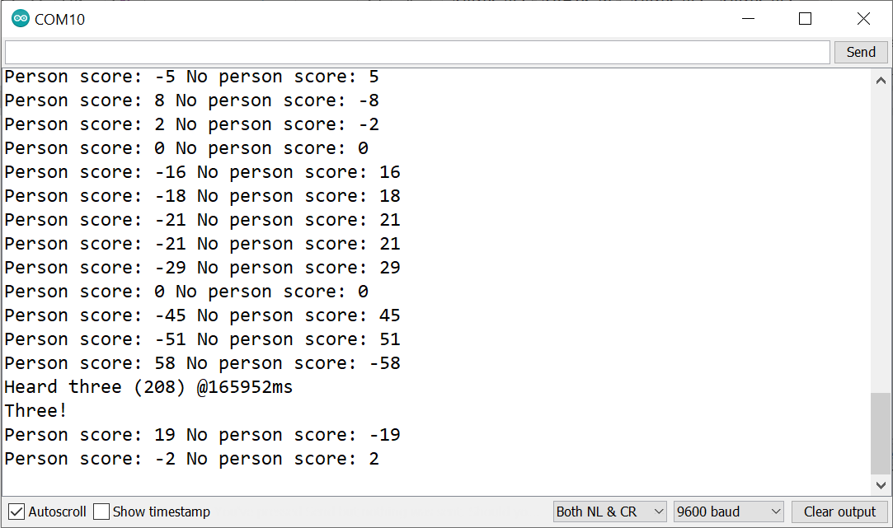

Person detected

Heard the number “Three”!

*Figure 4.6: Output of the KWS model inferences.*

The output hence obtained from the KWS inference is then displayed on the 7 Segment Display by using a 74LS595 Shift Register, as well as sent to the main elevator interface for controlling the elevator.

### Accuracy and Latency Observations

### During the testing phase of the hardware implementation, the model was robust and quick to respond to keywords and wake words. The accuracy so obtained while training the model of 83.5% and 84% for the VWW and KWS model is adequate and optimal.

### The model shows a latency low enough for it to be feasible as a practical product. The inference of the person detection model takes approximately 740 milliseconds, and an inference of the speech recognition model takes about 30 milliseconds.

### Bridging the Gaps Between The Hardware and The Simulations

Since the further parts of the results are conducted on simulation software such as Proteus Design Suite and TinkerCAD, there is a continuity break between the hardware and simulation pipeline.

To address this, we created the following system:

* The output of the KWS speech recognition model is printed on the serial monitor of the Arduino IDE as a number between one to four.
* The same input will be fed through the virtual monitor of the Proteus simulation to continue the further steps of the pipeline.
* In ideal implementation, the two systems will take inputs directly from each other without any physical human bridging.

## Software Based Simulations

The fire safety system inside and outside the elevator were implemented using simulation softwares, namely Proteus Design Suite and TinkerCAD. The simulations work in continuation of the hardware based person and speech detection systems, linked together using manual inputs from the user to correspond between the two.

### Display and Fire Safety System of the Outside (Floor) Unit on Proteus

The fire safety system outside the elevator bundled with the deployed unit was simulated on Proteus. The system consisted of the following components:

1. MQ-2 Smoke Detector System
2. LM-35 Temperature Sensor
3. 7 Segment Display using Shift Register
4. Alarm and Connection to Main Elevator Interface

Since the Arduino Nano 33 BLE Sense was not available as a library for simulation, we used the Arduino Nano baseline model for it. The architecture is similar and hence is adequate for the purposes of the project.

For the sake of completeness in the project, we chose to go create a pseudo-main elevator interface using an Arduino Uno in the simulation. A 4 x 16 LCD Display was also added for us to keep track of the system status.

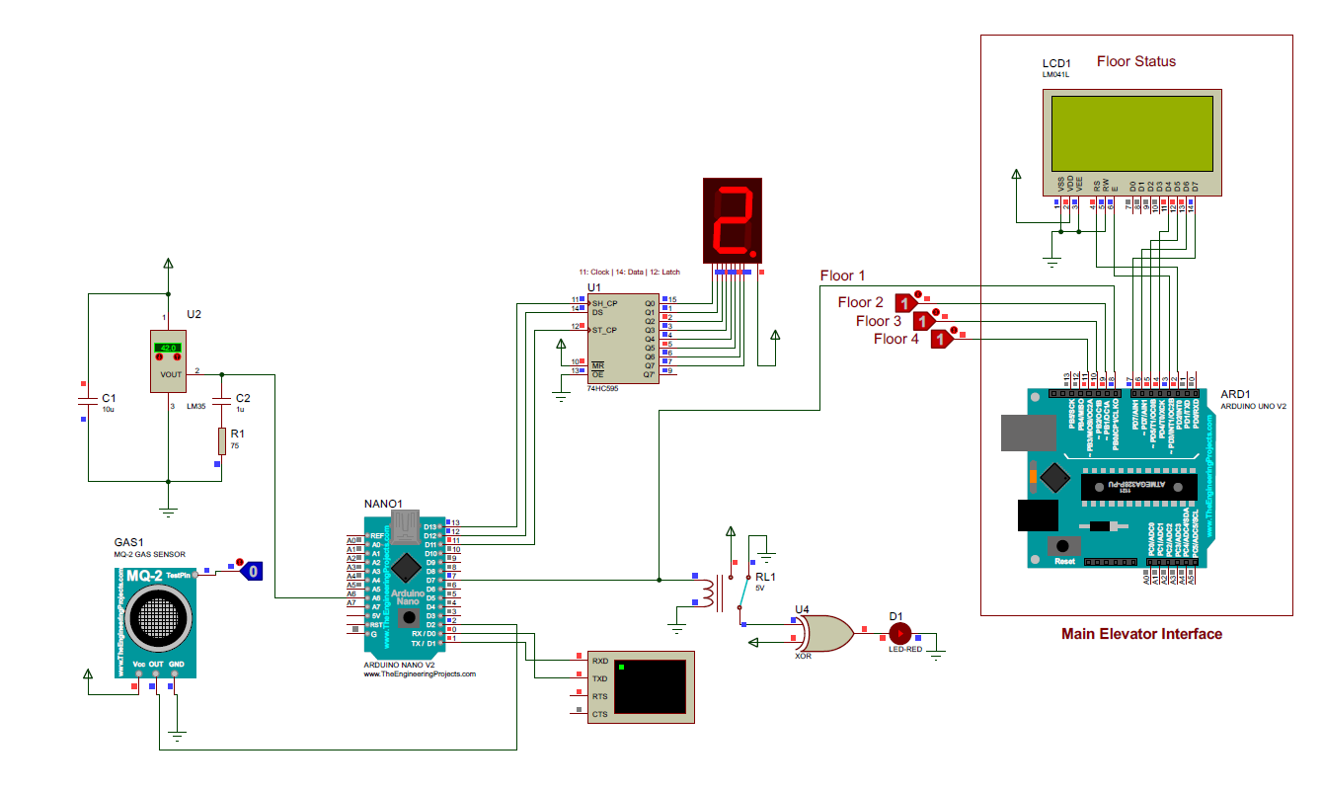Figure 4.7 shows the circuit schematic for the project on Proteus. The Arduino Nano is interfaced with a LM-35 and MQ-2 sensor, a 7 Segment Display and an alarm system which is triggered when the system is simulating a fire scenario.

*Figure 4.7: Outside Unit Simulation on Proteus*

### Working Overview

To maintain continuity between the hardware and the simulation, the user can input a floor number into the virtual terminal of the Arduino Nano on the Proteus Simulation. This floor number is displayed on the 7 Segment Display by using the *Serial.read()* method. This is shown in Figure 4.8.

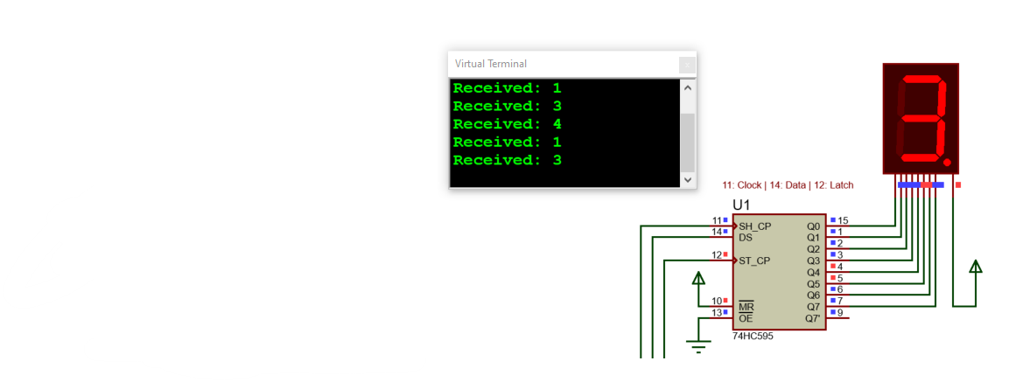

*Figure 4.8: Displaying the hardware output on the 7 Segment Display of the simulation.*

To simulate the situation of a fire, there are two options available in the simulation. These are:

1. Toggling of the MQ-2 Sensor state to indicate smoke/no-smoke.
2. Controlling the termperaure input to the LM-35 sensor to indicate high/low temperatures of a given room/floor.

In the simulation, the MQ-2 library gives only a digital output for the presence of smoke. Hence, for the scope of this simulation, we connected the sensor to a digital pin instead of an analog pin. In the actual implementation of the project, the sensor will be interfaces to an analog pin.

The threshold value for the LM-35 is 45oC, beyond which the alarm system will be triggered. Figure 4.9 (a) shows the state of the fire safety system when all parameters are optimal. Figure 4.9 (b) shows the state of the system when the temperature is above the threshold value. Figure 4.9 (c) displays the state of the system when the smoke detector has detected smoke (1 – smoke absent / 0 - smoke present).

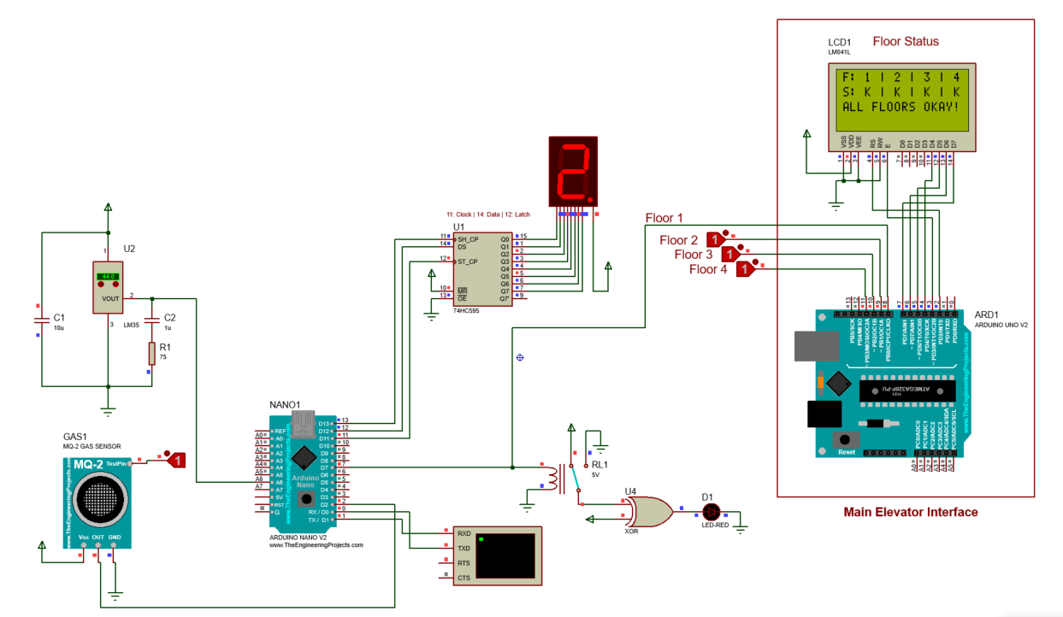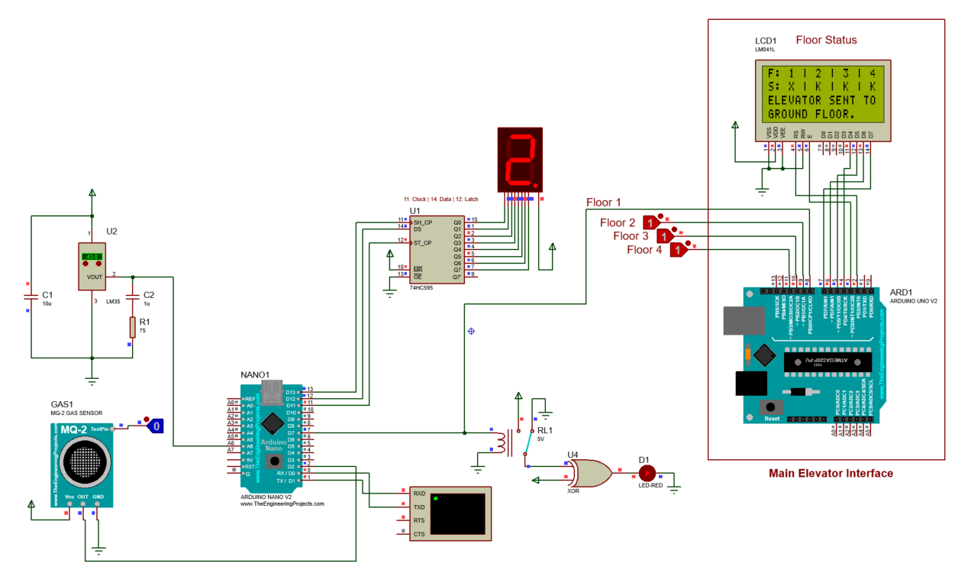

Alarm System Off

## *Figure 4.9 (a): Simulation when all parameters are optimal.*

Alarm System On

Floor flagged with “X”

## *Figure 4.9 (b): Simulation when smoke detector is set to 0 (smoke present).*

## *Figure 4.9 (c): Simulation when temperature is above 45oC and smoke detector is set to 0.*

Alarm System On

Floor flagged with “X”

Such units will be deployed on all floors of a given building. To simulate the output of multiple such floors, we used logic toggles which represent the state of the floor as a 1 (optimal) and 0 (danger). Figure 4.10 shows the usage of the toggle of floor 3 for example, and the change which is reflected in the LCD display.

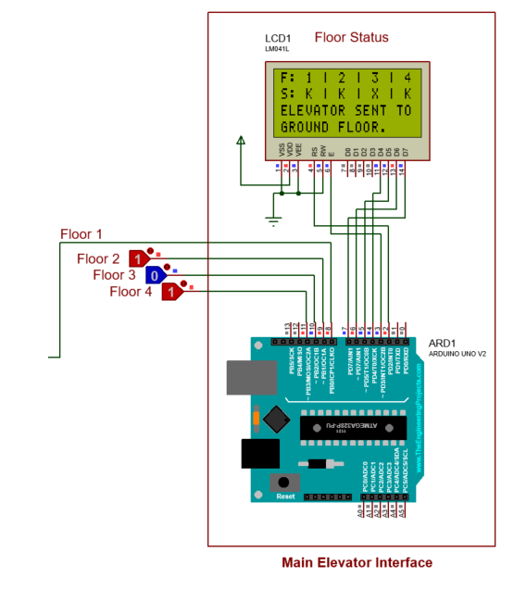

Floor 3 flagged with “X”

*Figure 4.10: Simulation state when an anomaly is detected on other floors (Example: Floor 3).*

### Limitations of the Simulation

In the simulation, the MQ-2 library gives only a digital output for the presence of smoke. Hence, for the scope of this simulation, we connected the sensor to a digital pin instead of an analog pin. In the actual implementation of the project, the sensor will be interfaces to an analog pin.

### Fire Safety System Inside The Elevator Unit on TinkerCAD

For a system to be complete, we proposed a comparator circuit within the elevator car which can notify the main interface about the status of smoke within it. We implemented this based on an IC741 Operational Amplifier circuit on TinkerCAD.

We went ahead with TinkerCAD against the choice of more advanced Proteus simulation software due to the analog capability of simulating smoke which was not possible in the latter. TinkerCAD serves as a great platform for basic circuitry such as the smoke detector circuit.

The schematic on a breadboard is shown in Figure 4.11. This circuit was made with reference to the datasheets of IC741 and the MQ-2 Smoke Detector.

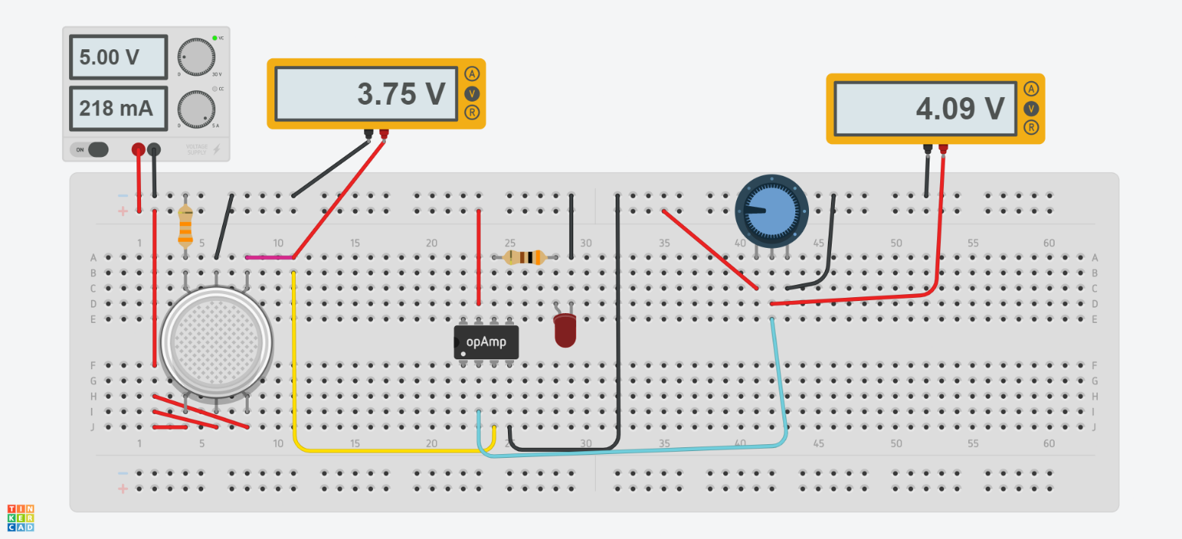

*Figure 4.11: Smoke detector circuit using IC741*

Through experimentation, the reference voltage of the circuit was set to be +4.09V by adjusting the potentiometer. Figure 4.12 shows the output of the circuit with low levels and high levels of smoke.

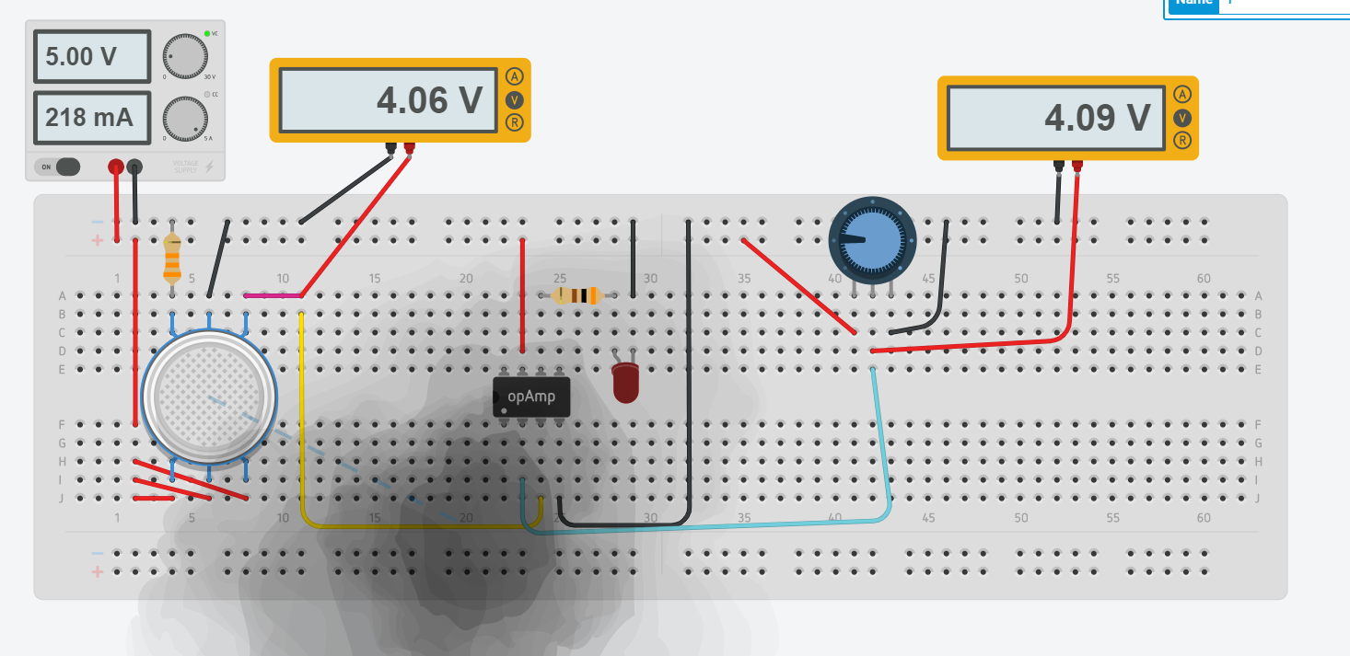

Low levels of smoke near the sensor.

*Figure 4.12 (a) Simulation when smoke is detected inside the elevator below threshold.*

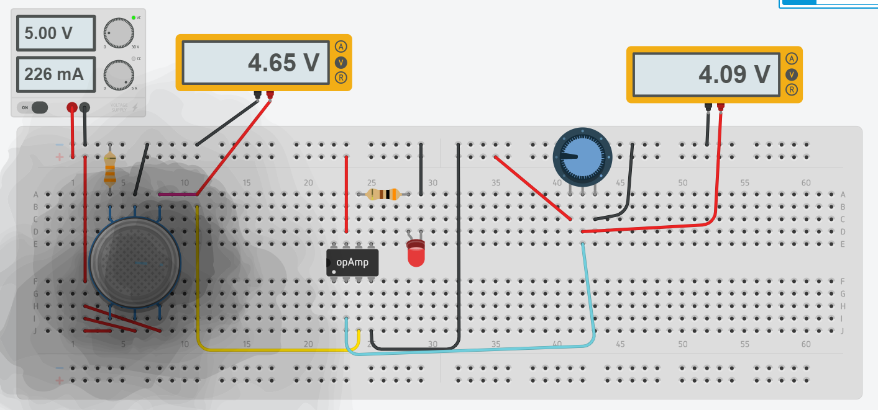

High levels of smoke near the sensor.

*Figure 4.12 (b) Simulation when smoke is detected inside the elevator above threshold.*

## PCB Design

## To house the components of this project, we created a Printed Circuit Board design using KiCAD, an open-source EDA software. Some key specifications of the PCB are:

## The PCB consists of 4 Copper layers.

## Front and Back Copper Layers are signal layers.

## Inner1 Copper layer contains a Power Plane.

## Inner2 Copper layer contains a Ground Plane.

## All components used utilize Through Hole Technology (THT) except for 74AHC1G86 Dual Input Single Output EX-OR Gate which uses SMT.

## Schematic

## The Eeschema file of the KiCAD build is shown in Figure 4.13. The complete detailed version of the same is also listed as Appendix 1.

## *Figure 4.13: PCB Schematic on KiCAD EDA.*

## Bill of Materials

## With reference to building a PCB, a Bill of Materials (BOM) is a comprehensive inventory of the raw materials, assemblies, subassemblies, parts, and components, as well as the quantities of each, needed to manufacture the board. The BOM for the designed PCB is given in Figure 4.14.

## *Figure 4.4: Bill of Materials for the PCB*

## PCB Layout

## As mentioned, the PCB is built of 4 copper layers. The layers from front to back are:

## Front Cu Signal Layer

## Power Plane Layer

## Ground Plane Layer

## Back Cu Signal Layer

## The layer schematics are as shown in Figure 4.15.

## *.*

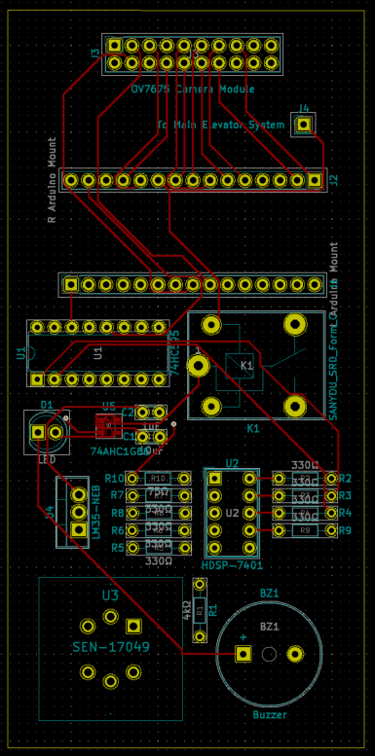 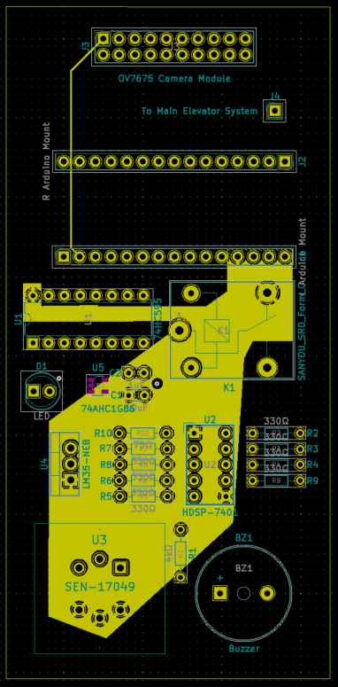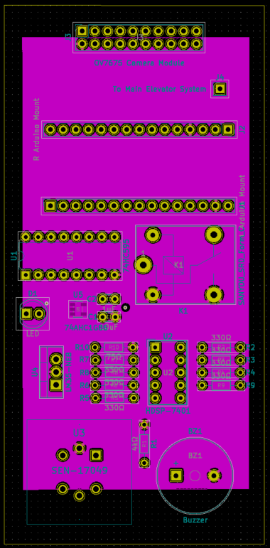 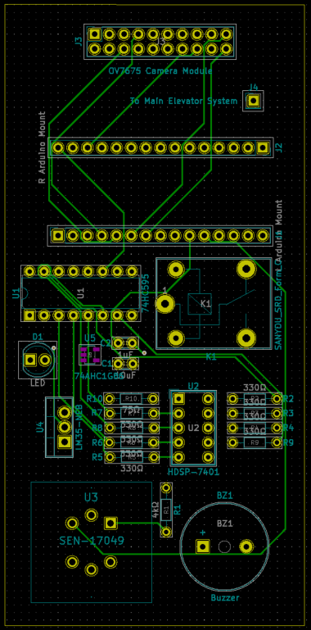

## *Figure 4.15: Four Copper layers of designed PCB.*

## 3D Renders of PCB

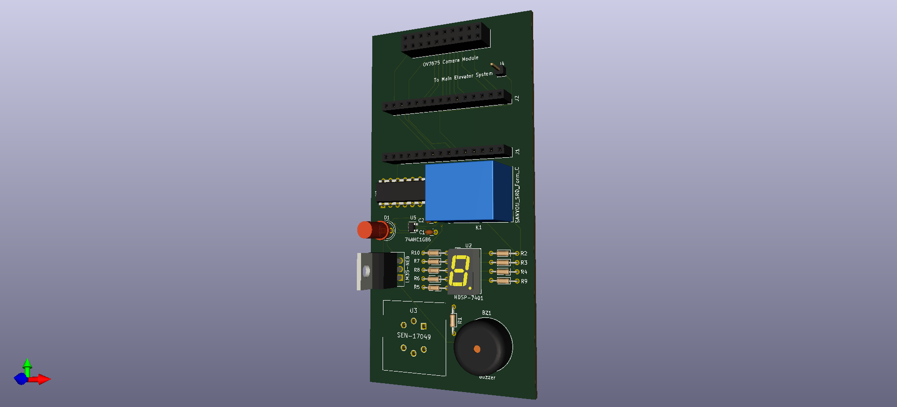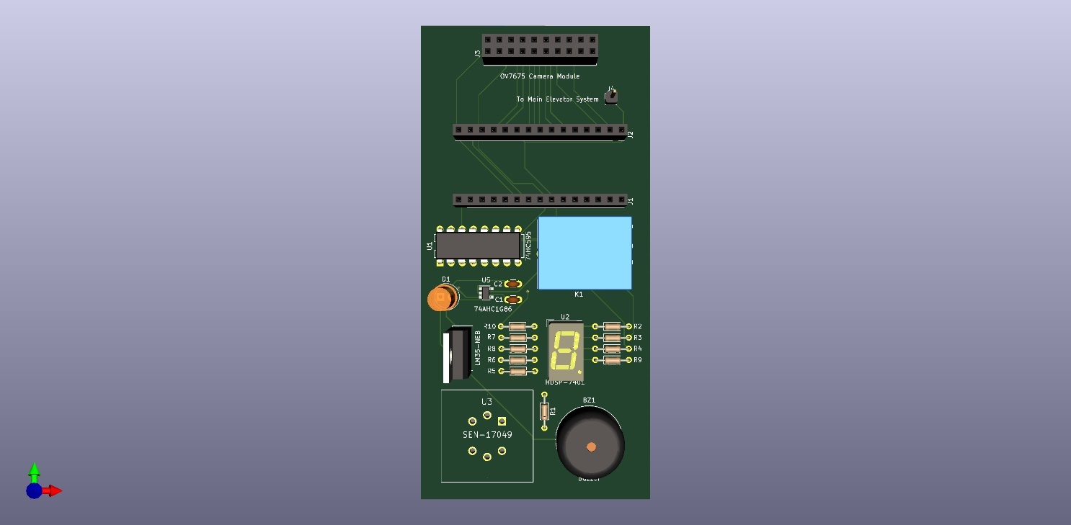Multiple angles of the 3D render generated by KiCAD are shown in Figure 4.16.

*Figure 4.16: 3D View of the designed PCB.*

# Conclusion

# Smart Elevator Systems Using Embedded Machine Learning and Fire Safety Mechanisms contributes to the domain of conventional elevators to improve current safety systems on various levels. The standard ways of implementing safety mechanisms include trap doors, phone systems inside the elevator for emergencies. Our project upgrades these systems in accordance to current needs. We have implemented machine learning to cater to the tasks based on keyword spotting and computer vision. Taking advantage of the TinyML system we used, we could do more with less cost incurred. We built a VWW model for the purpose of person detection. To create a speech recognition model, we had to extract certain features from the microphone signals, for which we employed a couple of ways, namely FFTs, Spectrograms and MFCCs. Once the user speaks, the raw data is captured and its FFT is generated, The Discrete ­ Fourier Transform of the data sampled over in a small unit of time makes up a small slice of the spectrogram therefore after taking multiple such Fourier Transforms of different timestamps of the incoming signal, we are able to form a single spectrogram which represents the variation of volume and frequency over time much better. We then generate a MFCC of the audio signal, and feed this to our neural network to get a much higher accuracy because of the extracted features than we would have using just the raw audio data. Thus, our model with its increased efficiency enables more automation for the comfort and safety of the users, allowing them to experience a touch-free elevator ride. Studies have shown that elevators elicit a form of fear in the population despite being normalized to a huge extent. This fear is caused because of the possible safety issues that they may compromise on in the status quo. In our model, we aimed to change that. We have also inculcated a smoke detector within the elevator which detects smoke and alerts the people inside the elevator, giving them buffer time to move out of the elevator and our fire safety system outside the elevator, which detects smoke and safety hazards outside the elevators and alerts the people. We therefore provide a holistic solution to everyday elevator-related problems faced.

# References

|  |  |
| --- | --- |
| [1] | Prof. Omkar M. Shete, Ms. Amrita A. Vitekar, Ms. Ashwini N. Patil, “Design & Control of an Elevator Control System using PLC,” *International Journal of Innovative Research in Electrical, Electronics, Instrumentation and Control Engineering,* vol. 5, 2017. |
| [2] | Max T. Kinateder, Hidemi Omori, Erica D. Kuligowski “The Use of Elevators for Evacuation in Fire Emergencies in International Buildings”, July 2014 |
| [3] | Arduino Nano 33 BLE Sense Schematics: https://content.arduino.cc/assets/NANO33BLE_V2.0_sch.pdf |
| [4] | Arduino Nano 33 BLE Sense Datasheet:  https://content.arduino.cc/assets/Nano_BLE_MCU-nRF52840_PS_v1.1.pdf |
| [5] | OV7675 Camera Module Datasheet:  https://www.uctronics.com/download/Image_Sensor/OV7675_DS.pdf |
| [6] | MQ-2 Gas Sensor Datasheet:  https://cdn.sparkfun.com/assets/3/b/0/6/d/MQ-2.pdf |
| [7] | LM-35 Temperature Sensor Datasheet:  https://www.ti.com/lit/ds/symlink/lm35.pdf |
| [8] | Common Anode Seven Segment Display:  https://docs.broadcom.com/docs/AV02-2553EN |
| [9] | 74HC595 Shift Register Datasheet:  https://www.ti.com/lit/ds/symlink/sn74hc595.pdf |
| [10] | 74AHC1G86 EX-OR Gate IC Datasheet:  https://www.diodes.com/assets/Datasheets/74AHC1G86.pdf |
| [11] | IC741 Operational Amplifier Datasheet:  https://www.ti.com/lit/ds/symlink/lm741.pdf |
| [12] | IC741 Operational Amplifier Datasheet:  https://www.ti.com/lit/ds/symlink/lm741.pdf |
| [13] | TensorFlow and Embedded Machine Learning:  https://www.edx.org/professional-certificate/harvardx-tiny-machine-learning |
| [14] | Daniel Situnayake, Pete Warden *“TinyML: Machine Learning with TensorFlow Lite on Arduino and Ultra-Low-Power Microcontrollers”*, December 2019 |

# Appendix

|  |  |
| --- | --- |
| [A] | PCB Design Schematic on KiCAD EDA |
| [B] | PCB pcbnew_ Design on KiCAD EDA |